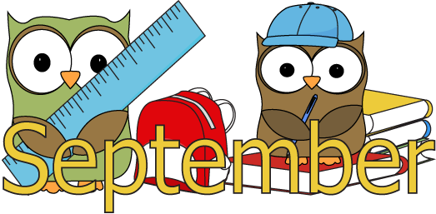

Reception Curriculum Newsletter – Autumn 1 2018

Dear Parents,
Our topic for the first half term is ‘Ourselves’. We would like to share an overview of the topic with you and some ways that you can support your child at home.

Area of Learning | Content | How you can help at home
Communication and Language | This term, children will be developing their listening skills by playing listening games, listening to each other during play activities and listening to and joining in with stories and rhymes.  Children will develop their speaking skills by being encouraged to share their ideas and talk about what is happening. | Encourage your child to listen to stories. Make sure that the TV is off and background noise is kept to a minimum.  Show interest in what your child is doing and encourage them to talk about their experiences. Talk about the pictures in story books as well as reading the stories.
English | Children will be starting to learn letter sounds (phonics) and how to segment and blend the sounds in words. They will be practising how to form letters correctly. They will also be learning how to write their names.  Children will be listening to stories every day and talking about the characters and settings. They will be learning to retell stories such as ‘Dear Zoo’ and ‘Ten in the Bed’. | Help your child to practise the letter sounds we send home in the phonics book, every day.  Help them to practise forming these letters correctly, starting in the correct place (as shown).  Share your child’s library book with them several times during the week. Encourage them to talk about what is happening in the pictures.  Your child will also bring home their first reading book before half-term. You can hear how the sounds are pronounced by searching for jolly phonics letter sounds on Youtube.
Mathematics | In Maths, children will be taking part in lots of counting activities, learning how to count in sequence (forwards and backwards) and how to count a small number of objects accurately. They will also learn to recognise and order numbers. | Help your child to practise counting up to 10 and back.  Help them to practise counting objects by touching each object and saying the number name.  Support them to recognise numbers up to 10.
Personal, Social and Emotional Development | This half term, children will be settling into school and learning the new routines. They will be meeting and getting to know the other children and adults in reception and developing confidence in choosing their own play activities. | Talk to your child about what they like to do at school and the people they like to play with.
Understanding the World  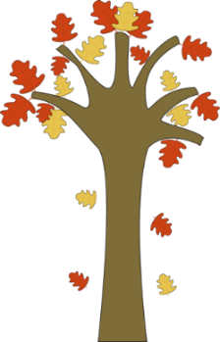 | Children will be using their senses to find out about the world around them. They will learn new vocabulary to help them to compare and describe objects e.g. hard and soft, rough and smooth, salty and sweet.  Children will be sharing their experiences of birthdays and talking about their families. | Encourage your child to talk about familiar objects, both inside and in the outdoor environment. Take time to find out what things feel like, talk about their colours, if they are shiny or what they might be made of.
Physical Development | This half term, children will be learning how to hold a pencil properly in order to form letter shapes confidently. They will be taking part in activities and games that involve negotiating space and moving in different ways. | Please support your child in learning how to put on and fasten their own coats and learning to take off and put on their shoes and sweatshirts by themselves.  Encourage children to use a pencil for writing and drawing as often as possible to develop confidence and an effective pencil grip.
Creative Development | Children will be playing in the role-play areas which are set up as a home and a baby clinic. This will give them to chance to learn new vocabulary and develop their imaginative play.  Children will be looking carefully at their faces and painting self-portraits and printing with their hands and feet. | Encourage children to make up stories about their toys. Instead of just pushing a car around the carpet, encourage them to talk about where it is going and what happens on the way. Encourage them to build play around familiar experiences, such as shopping or cooking food.

Next week children will be coming to school for their first week of full days. They will start at 8.40am and finish at 3.10pm. Mr Hirst, our Site Manager, has asked me to remind parents that Birks Fold can get very busy with traffic at these times of day and extra care should be taken to ensure that children are getting out of cars and crossing roads safely.

Now that the weather has started to become chillier and more showery, please could we remind you to send your child with a coat every day. Most children in Reception enjoy playing outside even if it is a bit rainy, so a coat is essential.

