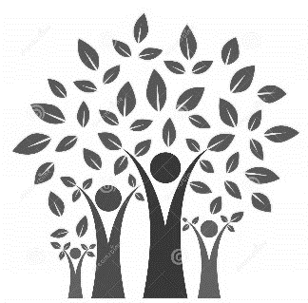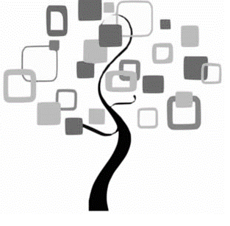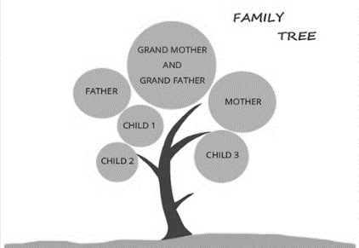

It may be big, it may be small; it may be close-knit, it may be spread around the world; it may be simple, it may be complicated. Whatever it is, your family is your family!
We want to celebrate families this holiday so Mrs Moran’s Holiday Homework is
My Family Tree
A family tree records the names of family members. It is often divided up into generations. You can start with yourself and work backwards or start with an ancestor and work forwards. You can make your family tree however you want to. You can include whoever you want to – as long as you include yourself!
There are hundreds of ideas on the Internet and even some templates you can download to help you. You can include as much or as little information as you want to.
Making it YOUR family tree:
You will need to speak to your parents and maybe your grandparents. Find out the names of family that you don’t know - your cousins or aunties and uncles you have never met.
You don’t have to include all your family – you might want to concentrate on one part of your family.
Once you have names, you need to organise them. How you do this is up to you. You have seen some ideas but you can organise your family however you want to!
Now make your family tree beautiful! You might have photos to put on the tree. Maybe you can draw members of your family or decorate their names. Maybe you can make it colourful in lots of different ways. Maybe you can reflect where your family are in the world.
We know that our children and their families have the most wonderfully creative ideas and will be excited to see your homework!
A note to parents: we will judge the children’s work in the same way we always do and may display it. If you would prefer that we didn’t display your child’s work for whatever reason, please either put a note on the work or send a dojo to Mrs Tomlinson. This will not affect the judging in any way.

