Reception Curriculum Newsletter – Spring 1 2019

Dear Parents,
Welcome back to a new term and a new year.
Dates for your diary.
Half term holiday: Finish: Friday 15th February
Return: Monday 25th February
Parent Consultation Evenings: Tuesday 2nd and Thursday 4th April
Easter Holiday: Finish: Friday 12th April
Return: Monday 29th April

Our topic for the first half term is ‘Fairy Stories and Traditional Tales’. We would like to share an overview of the topic with you and some ways that you can support your child at home.

Area of Learning | Content | How you can help at home
Communication and Language  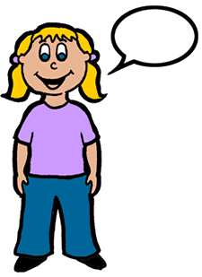 | This term, the children will be developing their listening skills by listening to and joining in with many stories. They will be developing their speaking skills by using story language to act out and retell familiar stories. Children will also be introduced to new vocabulary and develop their ability to give explanations. | Continue to share stories with your child. Spend time talking about the story and explaining any unfamiliar words.  Encourage your child to talk about things they have done and to explain their ideas. Encourage them to speak in full sentences.
English  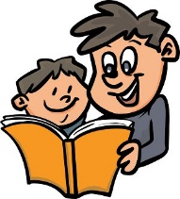 | Each week we will be reading a different fairy story or traditional tale. We will be talking about the different settings, characters and events in the story and learning to retell and write about the stories.  Children will be continuing to learn two new sounds each week. They will learn to blend the sounds for reading and use them in writing simple regular words. Children will be practising reading and writing simple captions and sentences. | Help your child to practise reading and writing the new letter sounds we send home in their phonics book, every day.  Share your child’s reading book with them several times during the week. Encourage your child to segment and blend the letter sounds together to read words.  Please help your child to read and write the ‘tricky’ words in the back of their phonics books.
Mathematics | In maths, we will be learning to add and subtract using numbers to 10. We will be continuing to practise counting forwards and backwards and finding ‘one more’ and ‘one less’ using numbers to 20.  We will be finding out about patterns and creating our own repeating patterns using different objects and materials.  We will also be learning to recognise 3D shapes, name them and describe them using mathematical language. | Please help your child to recognise all the numbers to 20 and say ‘one more’ or ‘one less’ than a given number in this sequence.  Help your child to look for patterns in everyday life e.g. a stripy pattern on a scarf or a pattern of bricks.  Help your child to look for different shapes in the environment e.g. a ball is a sphere, a box is a cuboid and a can is a cylinder.
Personal, Social and Emotional Development | At school, we will be continuing to encourage children to play co-operatively and take turns with other children. We will encourage children to become confident in trying new activities and talking to each other about their ideas. We will also be explaining why we need to keep school rules and helping children to take responsibility for their own actions. | Please encourage children to take turns and to listen to others.  Encourage them to try new things and to talk about some of the things they have learned to do at school or at home.
Understanding the World  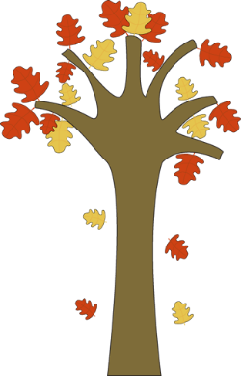 | Following on from our holiday homework, when children were asked to write and/or make pictures representing winter, we will be finding out more about this season and talking about the changes we can see in the natural world.  We will be visiting the local Morrisons supermarket to buy ingredients to make gingerbread men.  We will be looking at the changes that happen during cooking when we bake our gingerbread men. | Please support your child in looking at the changes in the natural world when you are ‘out and about’. Talk to them about the weather and the plants, trees and animals you can see.  Take your child to the supermarket and look at all the different signs and labels. Let your child help you to scan the shopping and pay for the items.  Let your child help you cook sometimes. Talk about the different ingredients and what they smell like, feel like and look like.
Physical Development | We will be finding out how to keep healthy and safe. This will include road safety, safety in the home and people who keep us safe.  We will continue to experiment with different ways of moving, such as running, skipping, climbing etc.  We will be learning to develop control over an object, such as a ball, by pushing, throwing, catching or kicking it. | Please continue to help your child to improve their pencil control and letter formation by encouraging them to write as often as possible.  Encourage your child to be as active as possible, for example, walking, running and playing games.
Creative Development | Our creative development will link with lots of the other areas of the curriculum. We will be painting pictures of the characters in the stories we are reading to link with English. We will be printing and using collage materials to make patterns to link with Maths. We will be mixing paints to make ‘cold colours’ and making collages in cold, wintry colours to link with Understanding the World. We will also be having a Cinderella Ball in the week before half term where children will be dancing to music. | Please encourage your child to draw pictures about things they are interested in or about favourite stories. Each holiday, we also set a more creative based homework, which allows your child to work with family members to make a picture or take photos of an activity. Please support your child to complete this homework.

