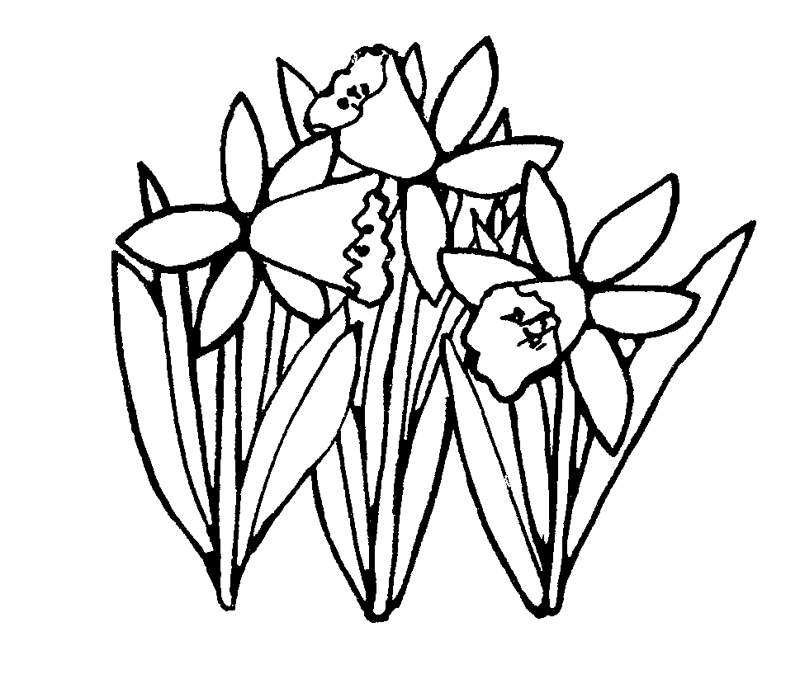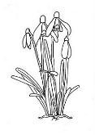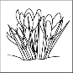

Spring Term Year 1 Newsletter

Happy New Year! Welcome back after the Christmas Holiday.

**Reminders:**

**Book bags-** please bring every day with reading book and reading record in. Please check these daily for any letters or work which your child brings home.

**Homework-** Your child will receive homework every Friday which they will need to complete and return to school by the following Tuesday. As part of the homework, please read with your child daily and sign their reading record. Each time a child finishes a book, they receive a tick on our Raving Readers board which puts them in line for receiving a book of their choice to keep.

**Belongings-** Please make sure all items of clothing are labelled clearly with your child’s name and class.

**P.E-** In Year 1 children come to school in their P.E kits on the days they have P.E. Your child needs to wear their P.E kit on Tuesday and Thursday.

**Seesaw-** Remember to use Seesaw to look at what your children have been doing in the school day.

**Dates for your diary:**

|  |  |
| --- | --- |
| Half term holiday: | Finish: Friday 15th February  Return: Monday 25th February |
| Parent Consultation Evenings: | Tuesday 2nd and  Thursday 4th April |
| Photograph Day: | Tuesday 6th March |
| Easter Holiday: | Finish: Friday 12th April  Return: Monday 29th April |
|  |  |

|  |  |  |
| --- | --- | --- |
| **Curriculum Area** | **Focus for learning** | **How you can help at home** |

|  |  |  |
| --- | --- | --- |
| Pen Clip Art**English**  http://images.clipartpanda.com/english-clipart-SecondaryBooks.gif | We will be reading lots of stories and be looking at story structure, so that children understand that there is a beginning, a middle and end to a story. The children will write their own stories using ideas from the stories that we have read. They will learn to write in sentences using the correct punctuation and using different openers. There will also be a real focus on using their cursive handwriting.  **Phonics:**  We teach and learn phonics every day. Each week the children will learn new sounds and revisit sounds already learnt. In June the children will be doing the Phonics check which tests their ability to sound out and blend words. | Talk to your child at home and model skills such as listening, taking turns and speaking in full sentences.  Ask your child what s/he has learnt at school each day.  Listen to your child read daily and also read and talk about lots of different stories with them.  Please ensure your child brings their book bag to school daily with all reading books in.  Please write in the reading record book when you listen to your child read.  Chant the alphabet to learn the letter names  Help your child to practise handwriting using the school pre-cursive handwriting font.  Practise spelling the ‘tricky’ words that we have been learning. |
| **Maths**  Image result for maths b&w | This term we will continue to focus on place value and counting forwards and backwards up to and beyond 100. Also we will keep developing our addition and subtraction skills. Multiplication and division are part of the Y1 curriculum and we are continuing to learn the 2, 10 and 5 times tables this term.  We will be learning to tell the time (o’clock and half past)  We will also be exploring the characteristics of shapes, and considering how objects can be ordered by length or weight. | Help your child to recognise the numbers 0 to 100 and spot numbers when you are out and about.  Whilst playing games at home, or at any other opportunity, encourage your child to count with 1:1 correspondence.  Help your child to notice shapes within their local environment.  Talk to your child as you weigh or measure things at home.  Use the clock at home, tell them the time and encourage them to tell you what time it is as they become more confident. |
| Image result for scienceclip art b&wImage result for scienceclip art b&wImage result for BIOLOGY clip art b&wMicroscope 20clipart | Clipart library - Free Clipart ImagesRelated image**Science** | Our Science topic this term is about Animals including humans. We will identify, name, draw and label the basic parts of the human body and say which part of the body is associated with each sense.  We will be learning to identify and name a variety of common animals that are birds, fish, amphibians, reptiles, mammals and invertebrates  We will identify and name a variety of common animals that are carnivores, herbivores and omnivores.  We will describe and compare different animals (birds, fish, amphibians, reptiles, mammals and invertebrates, and including pets) | Sing songs, point to body parts and check that your child can name these. Taste different foods and get your child to describe what they can taste. Listen to music and listen out for different sounds  You could use books and the environment to look at and talk about animals.  There are many videos and TV programmes for children to learn about animals. |
| **R.E.** | In RE we will be learning about special texts from the Christian, Jewish and Muslim faiths. | Talk to your child about what is special to them and your family. |
| **Image result for fitness clip art b&wP.E.**  **Image result for fitness clip art b&w** | We will be developing our skills for movement this term and learning dance skills. | Praise your child as they explore new ways of balancing and travelling, such as hopping or skipping. |
| **Creative Curriculum**  Related imageImage result for painting clipart b&w -zoneImage result for scissors clipart b&w -zoneImage result for hammer clipart b&w -zoneImage result for history  clipart b&w -zone  **(History, Geography Art or DT)** | We will be learning about the countries and capitals of the United Kingdom,  discovering some of the physical and human features of the United Kingdom and carrying out an in-depth study of the location of the school. | Visit the library or use the internet to learn about the UK.  Talk to your children about what you can see around in Lidget Green/ Bradford .e.g. the buildings, shops, the surrounding countryside etc. |
| Image result for music clipart b&w -zone**Music** | We will be using Charanga this term and will learn to play instruments and sing songs. | Ask your child to teach you the rhymes and songs they have been learning at school. |
| **Computing**  Image result for computer coding clipart b&w -zone | To add data to a table and display it as a graph | Use a PC/laptop at home or at the library to help your child to learn to use the keyboard and mouse. |