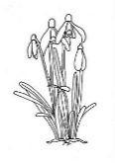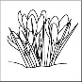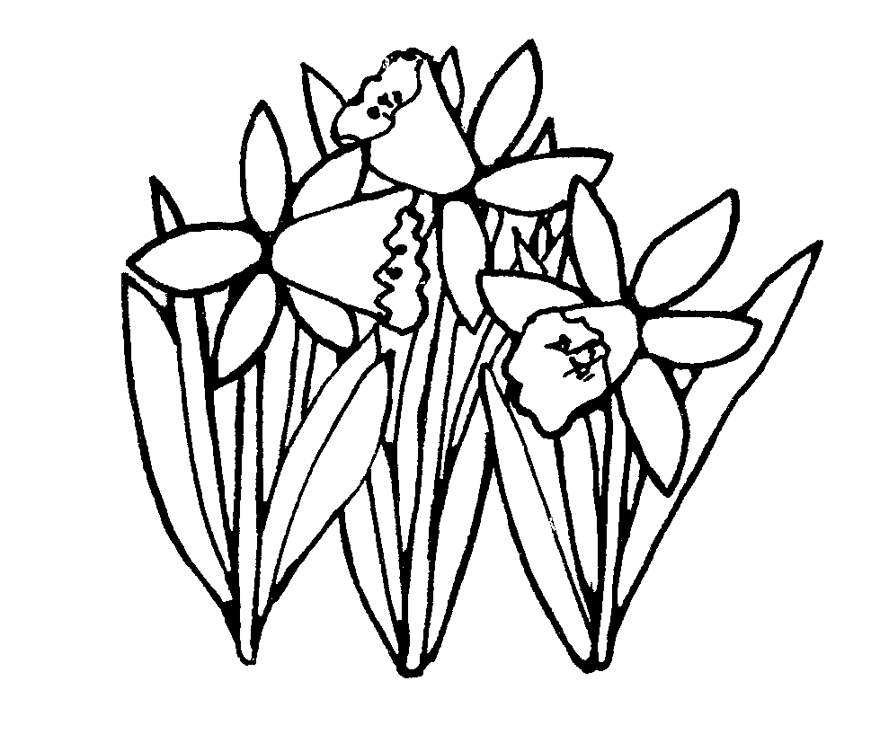**Spring Term 2019 – 6L Newsletter**

**Happy New Year – I hope you’ve had a lovely break!**

**This term is very important for Year 6 children as they approach the mid-point of their final year in Primary School. Please ensure your child comes to school ready to learn every day!**

Uniform Reminder: Some children are not wearing the correct uniform every day. Children may come to school in their PE kits on Mondays and Wednesdays (outdoor PE so children may also bring a raincoat and hat). On all other days, children should come to school in full uniform which includes black shoes. **If they have a sports club or competition, they should bring their PE kit in a bag to change into**.

SATs revision:Some parents have asked about helping their child prepare for SATs at home. The best way to help your child is to support them in the homework that is set by the class teacher. If you would like to buy extra books for your child, Collins and CGP are good – make sure they are for KS2 SATs. I will also give out some materials at our next parents’ evening in March.

Class Dojo and Seesaw: Some parents are still not signed up for Class Dojo and Seesaw. Important reminders are sent out regularly via class dojo and it is a great way for us to keep in touch with you and vice versa. By signing up to Seesaw, you can see your child’s work and your child can access extra homework set by the teacher. If you need help signing up to either of these, please ask your child’s teacher.

**Dates for your diary:**

|  |  |  |  |
| --- | --- | --- | --- |
| Half term holiday: | | Finish: Friday 15th February  Return: Monday 25th February | |
| Parent Consultation Evenings: | | Tuesday 2nd and Thursday 4th April | |
| Photograph Day: | | Tuesday 6th March | |
| Easter Holiday: | | Finish: Friday 12th April  Return: Monday 29th April | |
| SATs: | | Monday 13th – Thursday 16th May | |
| **Curriculum Area** | **Focus for learning** | | **How you can help at home** |
| Pen Clip Art**English**  http://images.clipartpanda.com/english-clipart-SecondaryBooks.gif | This term we are reading the book ‘Eye of the Wolf’. We will be doing lots of different styles of writing, particularly focusing on vocabulary and punctuation. | | Ensure your child is reading good quality books at home on a daily basis Encourage your child to keep a list of new vocabulary they learn and use it at home. |
| **Maths**  Image result for maths b&w | This term we will be focussing on algebra, area and perimeter, decimals, statistics, graphs, time, grid references and percentages. We will also be combining all areas of knowledge to do some problem solving. | | Ensure your child does their maths homework every week. If they don’t already know their times tables, rehearse these daily – use Rockstars. Encourage your child to tell you about what they have been learning. |
| Related imageMicroscope 20clipart | Clipart library - Free Clipart ImagesImage result for scienceclip art b&wImage result for BIOLOGY clip art b&w**Science**Image result for scienceclip art b&w | This term we will be learning about evolution and inheritance in animals and humans. | | Discuss your own family tree – what traits have been passed down through the generations? What is your heritage? |
| **R.E.** | This term we will be learning about how different religious communities worship, about the soul and about meditation. | | Ask children about what they have been learning. Talk to your children about your own experiences of worship. |
| **Image result for fitness clip art b&wImage result for fitness clip art b&wP.E.** | This term we will be doing gymnastics indoor and netball/basketball outdoor. | | Keep active with your child. Encourage them to exercise at home or go for walks as a family. |
| Image result for scissors clipart b&w -zone**Creative Curriculum**  Related imageImage result for hammer clipart b&w -zoneImage result for painting clipart b&w -zoneImage result for history  clipart b&w -zone | This term we are learning about biomes, human and physical geography – specifically in Africa. After February half term, we will be learning about earthquakes and volcanoes. | | Encourage your child to use the internet - or the library - to do some wider research on what they learn in school. |
| http://users.wpi.edu/~mmurphy/images/spanish.png**Spanish** | This term we will be learning vocabulary for weather. We will be creating our own weather forecasts and looking at the weather in different Spanish speaking countries. | | Ask your child about the vocabulary they have learned each week. Watch the weather forecast on TV or look it up each day. |
| **Computing**  Image result for computer coding clipart b&w -zone | The children are producing their own animation using digital animating software. We will be also looking at online safety and talking about how to keep private information off line. | | Talk to your children about how they use their devices at home and what apps they are using online. |

**Spring Term 2019 – 6G Newsletter**

**Happy New Year – I hope you’ve had a lovely break!**

**This term is very important for Year 6 children as they approach the mid-point of their final year in Primary School. Please ensure your child comes to school ready to learn every day!**

Uniform Reminder: Some children are not wearing the correct uniform every day. Children may come to school in their PE kits on Fridays and Wednesdays (outdoor PE so children may also bring a raincoat and hat). On all other days, children should come to school in full uniform which includes black shoes. **If they have a sports club or competition, they should bring their PE kit in a bag to change into**.

SATs revision:Some parents have asked about helping their child prepare for SATs at home. The best way to help your child is to support them in the homework that is set by the class teacher. If you would like to buy extra books for your child, Collins and CGP are good – make sure they are for KS2 SATs. I will also give out some materials at our next parents’ evening in March.

Class Dojo and Seesaw: Some parents are still not signed up for Class Dojo and Seesaw. Important reminders are sent out regularly via class dojo and it is a great way for us to keep in touch with you and vice versa. By signing up to Seesaw, you can see your child’s work and your child can access extra homework set by the teacher. If you need help signing up to either of these, please ask your child’s teacher.

**Dates for your diary:**

|  |  |  |  |
| --- | --- | --- | --- |
| Half term holiday: | | Finish: Friday 15th February  Return: Monday 25th February | |
| Parent Consultation Evenings: | | Tuesday 2nd and Thursday 4th April | |
| Photograph Day: | | Tuesday 6th March | |
| Easter Holiday: | | Finish: Friday 12th April  Return: Monday 29th April | |
| SATs: | | Monday 13th – Thursday 16th May | |
| **Curriculum Area** | **Focus for learning** | | **How you can help at home** |
| Pen Clip Art**English**  http://images.clipartpanda.com/english-clipart-SecondaryBooks.gif | This term we are reading the book ‘Eye of the Wolf’. We will be doing lots of different styles of writing, particularly focusing on vocabulary and punctuation. | | Ensure your child is reading good quality books at home on a daily basis Encourage your child to keep a list of new vocabulary they learn and use it at home. |
| **Maths**  Image result for maths b&w | This term we will be focussing on algebra, area and perimeter, decimals, statistics, graphs, time, grid references and percentages. We will also be combining all areas of knowledge to do some problem solving. | | Ensure your child does their maths homework every week. If they don’t already know their times tables, rehearse these daily – use Rockstars. Encourage your child to tell you about what they have been learning. |
| Related imageMicroscope 20clipart | Clipart library - Free Clipart ImagesImage result for scienceclip art b&wImage result for BIOLOGY clip art b&w**Science**Image result for scienceclip art b&w | This term we will be learning about evolution and inheritance in animals and humans. | | Discuss your own family tree – what traits have been passed down through the generations? What is your heritage? |
| **R.E.** | This term we will be learning about how different religious communities worship, about the soul and about meditation. | | Ask children about what they have been learning. Talk to your children about your own experiences of worship. |
| **Image result for fitness clip art b&wImage result for fitness clip art b&wP.E.** | This term we will be doing gymnastics indoor and netball/basketball outdoor. | | Keep active with your child. Encourage them to exercise at home or go for walks as a family. |
| Image result for scissors clipart b&w -zone**Creative Curriculum**  Related imageImage result for hammer clipart b&w -zoneImage result for painting clipart b&w -zoneImage result for history  clipart b&w -zone | This term we are learning about biomes, human and physical geography – specifically in Africa. After February half term, we will be learning about earthquakes and volcanoes. | | Encourage your child to use the internet - or the library - to do some wider research on what they learn in school. |
| http://users.wpi.edu/~mmurphy/images/spanish.png**Spanish** | This term we will be learning vocabulary for weather. We will be creating our own weather forecasts and looking at the weather in different Spanish speaking countries. | | Ask your child about the vocabulary they have learned each week. Watch the weather forecast on TV or look it up each day. |
| **Computing**  Image result for computer coding clipart b&w -zone | The children are producing their own animation using digital animating software. We will be also looking at online safety and talking about how to keep private information off line. | | Talk to your children about how they use their devices at home and what apps they are using online. |

**Spring Term 2019 – 5/6P Newsletter**

**Happy New Year – I hope you’ve had a lovely break!**

**This term is very important for our Year 6 children as they approach the mid-point of their final year in Primary School. Please ensure your child comes to school ready to learn every day!**

Uniform Reminder: Some children are not wearing the correct uniform every day. Children may come to school in their PE kits on Fridays and Mondays (outdoor PE so children may also bring a raincoat and hat). On all other days, children should come to school in full uniform which includes black shoes. **If they have a sports club or competition, they should bring their PE kit in a bag to change into**.

SATs revision:Some parents have asked about helping their child prepare for SATs at home. The best way to help your child is to support them in the homework that is set by the class teacher. If you would like to buy extra books for your child, Collins and CGP are good – make sure they are for KS2 SATs. I will also give out some materials at our next parents’ evening in March.

Class Dojo and Seesaw: Some parents are still not signed up for Class Dojo and Seesaw. Important reminders are sent out regularly via class dojo and it is a great way for us to keep in touch with you and vice versa. By signing up to Seesaw, you can see your child’s work and your child can access extra homework set by the teacher. If you need help signing up to either of these, please ask your child’s teacher.

**Dates for your diary:**

|  |  |  |  |
| --- | --- | --- | --- |
| Half term holiday: | | Finish: Friday 15th February  Return: Monday 25th February | |
| Parent Consultation Evenings: | | Tuesday 2nd and Thursday 4th April | |
| Photograph Day: | | Tuesday 6th March | |
| Easter Holiday: | | Finish: Friday 12th April  Return: Monday 29th April | |
| SATs: | | Monday 13th – Thursday 16th May | |
| **Curriculum Area** | **Focus for learning** | | **How you can help at home** |
| Pen Clip Art**English**  http://images.clipartpanda.com/english-clipart-SecondaryBooks.gif | This term we are reading the book ‘Eye of the Wolf’. We will be doing lots of different styles of writing, particularly focusing on vocabulary and punctuation. | | Ensure your child is reading good quality books at home on a daily basis Encourage your child to keep a list of new vocabulary they learn and use it at home. |
| **Maths**  Image result for maths b&w | This term we will be focussing on algebra, area and perimeter, decimals, statistics, graphs, time, grid references and percentages. We will also be combining all areas of knowledge to do some problem solving. | | Ensure your child does their maths homework every week. If they don’t already know their times tables, rehearse these daily – use Rockstars. Encourage your child to tell you about what they have been learning. |
| Related imageMicroscope 20clipart | Clipart library - Free Clipart ImagesImage result for scienceclip art b&wImage result for BIOLOGY clip art b&w**Science**Image result for scienceclip art b&w | This term we will be learning about evolution and inheritance in animals and humans. | | Discuss your own family tree – what traits have been passed down through the generations? What is your heritage? |
| **R.E.** | This term we will be learning about how different religious communities worship, about the soul and about meditation. | | Ask children about what they have been learning. Talk to your children about your own experiences of worship. |
| **Image result for fitness clip art b&wImage result for fitness clip art b&wP.E.** | This term we will be doing gymnastics indoor and netball/basketball outdoor. | | Keep active with your child. Encourage them to exercise at home or go for walks as a family. |
| Image result for scissors clipart b&w -zone**Creative Curriculum**  Related imageImage result for hammer clipart b&w -zoneImage result for painting clipart b&w -zoneImage result for history  clipart b&w -zone | This term we are learning about biomes, human and physical geography – specifically in Africa. After February half term, we will be learning about earthquakes and volcanoes. | | Encourage your child to use the internet - or the library - to do some wider research on what they learn in school. |
| http://users.wpi.edu/~mmurphy/images/spanish.png**Spanish** | This term we will be learning vocabulary for weather. We will be creating our own weather forecasts and looking at the weather in different Spanish speaking countries. | | Ask your child about the vocabulary they have learned each week. Watch the weather forecast on TV or look it up each day. |
| **Computing**  Image result for computer coding clipart b&w -zone | The children are producing their own animation using digital animating software. We will be also looking at online safety and talking about how to keep private information off line. | | Talk to your children about how they use their devices at home and what apps they are using online. |