Lidget Green Primary School
Birks Fold, Lidget Green
Bradford
BD7 2QN

T: (01274) 579576
www.lidgetgreen.net
17.3.20
Dear parents/carers,

I am writing to update you on our emergency plans linked to the Coronavirus.

- Following the announcement from the government last night, schools have been directed to remain open. If we are told to close school in the next few days or weeks we will contact parents via Class Dojo and post the closure on the Bradford Schools Online website, just as we do for a snow day closure. If you are not signed up to Class Dojo please speak to the office staff who will assist you in registering. It is vital that all parents are on Class Dojo as we will use it to communicate with you over the coming weeks.

- We continue to follow the health and safety guidance from Public Health England with regard to health and hygiene. We are still being advised to promote regular and thorough handwashing as the key strategy to protect against the spread of the virus.
- From now on, if one person in a household starts to display flu-like symptoms - defined as a fever of above 37.8C or a persistent cough - everyone living there must stay at home for 14 days.

Can I please reiterate the importance of 14 day self-isolation for children who have the key symptoms of Coronavirus: persistent cough and /or a high temperature. If your child has these symptoms please do not send them into school for 14 days. We will authorise these absences under the exceptional circumstances code.

I regret that we have had to cancel a number of events planned in school over the coming weeks, these are:
- Parents consultation evenings (31st & 2nd April)
- All school trips

I will continue to keep you informed of any further developments based on the government advice. If you have any queries or questions, please do not hesitate to contact me.

Yours sincerely

Mrs C Moran
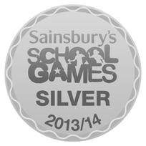
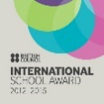
Headteacher

