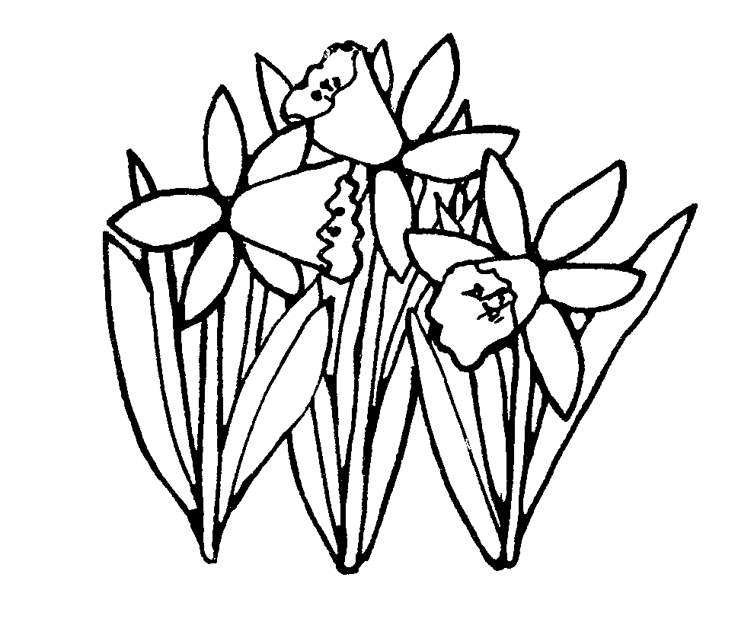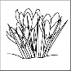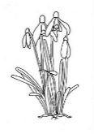

Spring Term Year 2 Class Newsletter

I hope you all had a wonderful Christmas holiday and are looking forward to the exciting new year ahead.

The following information will provide you with an insight into what the children will be learning this term in Year 2. If you have any issues or concerns, please do not hesitate to contact us via class dojo, speak to us at home time or make an appointment through the school office. We are looking forward to a very positive and rewarding year where we can all work co-operatively to enable your child to reach their full potential.

**Dates for your diary:**

Monday 28th March Parent Consultation Evening

Wednesday 30th March Parent Consultation Evening

Friday 18th February School closes for Half Term Break

Monday 28th February School re-opens

Friday 8th April School closes for Easter Holidays

Monday 25th April School re-opens

|  |  |  |
| --- | --- | --- |
| **Curriculum Area** | **Focus for learning** | **How you can help at home** |
| Pen Clip Art**English**  http://images.clipartpanda.com/english-clipart-SecondaryBooks.gif | We will start the year by reading Zog and the Flying Doctors by Julia Donaldson. We’ll focus on character descriptions using adjectives and expanded noun phrases. We will also begin writing our own stories following the pattern of Zog. We will read some non-fiction texts about castles, learning about their features and writing reports about what we have learnt. In the second term we will start our topic of ‘Proud to Be From Bradford’. We will be writing reports and leaflets about the buildings of the city centre | Encourage your child to read aloud to you at home. Make sure the books are challenging enough and provide them with new experiences.  If you can, provide your children with paper or a notebook where he/she can draw and write. |
| **Maths**  Image result for maths b&w | The children will be looking at basic place value and addition and subtraction of one and two-digit numbers.  The children will also be looking at multiplication and division and building on their basic number skills. We will also begin looking at measurement (length), fractions and money. | Help your child to practise their 2, 5 and 10 times tables.  Using the ‘Times Table Rockstar’ App regularly will help to develop fluency in knowledge and recall of times tables. |
| Image result for scienceclip art b&wImage result for BIOLOGY clip art b&wMicroscope 20clipart | Clipart library - Free Clipart ImagesRelated image**Science**Image result for scienceclip art b&w | We will be looking at materials this term. We will learn why certain materials are suitable for certain purposes. We will look at everyday materials that we use around our school and home. | Talking to your children about the work they have been doing, helps them to understand and remember the scientific knowledge they have been learning in class.  Reading non-fiction texts linked to materials will help develop their understanding further. |
| **R.E.** | The children will be exploring the beliefs and practices of religions such as Islam and Christianity. They will learn to express their own ideas, opinions and experiences. | Discuss with your child what they learnt about the different beliefs and religious practices. |
| **Image result for fitness clip art b&wP.E.**  **Image result for fitness clip art b&w** | The children will be learning gymnastics skills and medieval dancing. They will also be learning fundamental skills such as balancing, throwing and catching. | Please check that your child comes in the correct PE kit.  Discuss with your child what skills they have learnt in PE. |
| **Topic**  Related imageImage result for painting clipart b&w -zoneImage result for scissors clipart b&w -zoneImage result for hammer clipart b&w -zoneImage result for history  clipart b&w -zone  **(History, Geography)** | This half term we have a History focus so we will be looking at castles. We will be looking at what castles are made of and why they were built. We will learn about how castles were defended and why we don’t all live in castles now. Our ‘Proud to be from Bradford’ topic will also be a history topic where we look at the buildings of our city centre – what are their purposes and how have they changed over time. We will also cover some Geography in this topic including map skills, the compass rose, and the human and physical features of Bradford. | Ask children about what they have learnt. Put ‘DK Find out castles’ into your search engine and explore castles on the website. If you’re able to, visit the city centre and have a walk around City Park and the surrounding area. Ask your child to look the monuments near the Alhambra Theatre – can you find out why they were built? |
| **Art/DT**  Information And Facts That Will Help You With Crafts And Art | The children will be exploring different media and materials. They will be using paint, wax crayons, water colours. | Discuss with children the new techniques and methods they have learnt in lessons. What can they tell you about the artists and art forms? |
| **Computing**  Image result for computer coding clipart b&w -zone | Children will be learning about internet safety. They will learn how to use technology purposefully to create, organise, store, manipulate and retrieve digital content. We will also continue to develop keyboard skills (typing). | Discuss with children the new things they have learnt about computing. Practice the skills at home using Purple Mash or any other programme you have that encourages your child to write and draw on a device. |