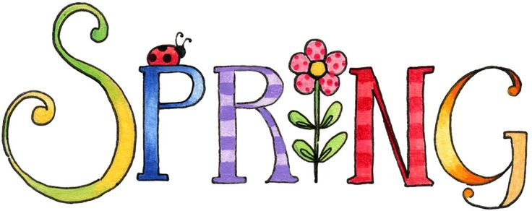

Spring Term

Year 3 Newsletter

Welcome to the new Spring term! We hope that you all had an enjoyable and relaxing holiday!

**Dates for your diary:**

**Half term holiday:** Break-up: 18thFebruary 2022

Re-open: 28th February 2022

**Parent Consultation** **Evenings: Monday 28th March**

**Wednesday 30th March 2022**

**Easter Holiday:** Break-up: 8th April 2022

Re-open: 25thApril 2022

|  |  |  |
| --- | --- | --- |
| **English**  http://images.clipartpanda.com/english-clipart-SecondaryBooks.gifPen Clip Art | In English we will be learning about mystery stories.  Over the course of the unit, children will be focusing on descriptive writing using expanded noun phrases, perfect tense, speech, similes and metaphors to make their writing more interesting. | ☺ Read with your child as much as possible, asking questions about the book they are reading.  ☺Please encourage your child to practise spellings. Try asking the children to say the words, find the meaning and write them in sentence.  ☺ Look at some mystery stories together and talk about the language used to describe the setting and characters. |
| **Maths**  Image result for maths b&w | The children will continue to develop their mathematical skills in the following areas; addition, subtraction, fractions, multiplication and division.  Alongside this we will be focusing on measurement of length, mass, capacity and learning about money.  We will continue to practise our timetables (2,3,4,5,8 and 10). | ☺ Spot numbers around the house and when you’re out and about. Ask your child to compare the numbers – which is larger? Which is smaller? How many tens in the number? How many ones? Encourage the use of the four operations (add, subtract, multiply and divide) in different contexts.  ☺Keep practising the times tables! By the end of this year children need to know their 2, 3, 4, 5 8 and 10 times tables.  ☺Encourage your child to count money by playing role play games or taking them shopping!  ☺ Let your child help you in the kitchen to work on measurement or around the house doing DIY! |
| Image result for scienceclip art b&wImage result for BIOLOGY clip art b&wMicroscope 20clipart | Clipart library - Free Clipart ImagesRelated image**Science**Image result for scienceclip art b&w | In Science, we are learning about Light by exploring what happens when light reflects off a mirror or other reflective surfaces. We will look at how shadows are formed and how light is reflected. We will also learn about animals including humans. We will learn what animals and humans need to maintain a healthy body and about different types of skeleton. Children will identify that humans and some other animals have skeletons and muscles for support, protection and movement. | ☺ It would help your child to visit the library or use the internet to find out more information about these topics. |
| **R.E.** | Children will be exploring the big question: What do people believe about God? | ☺ Encourage your child to visit the library or use the internet to find out more information about these topics |
| **Image result for fitness clip art b&wP.E.**  **Image result for fitness clip art b&w** | During P.E lesson, we will be learning to play net and ball games. | ☺Encourage your child to practise these skills at home.  Make sure your chid has suitable P.E kit on each day. |
| **Music**  Image result for music clipart b&w -zone | We will be learning songs that are inspired by words and stories. We will learn to listen, chant and sing. | ☺Sing with your child whenever you can. Traditional songs, pop songs, religious songs – all will help them build their singing stamina and improve their tone and pitch. |
| **History and Geography**  Related imageImage result for painting clipart b&w -zoneImage result for history  clipart b&w -zone | In geography we will be looking at our location, cities and counties of the UK and we will be learning about Saltaire. | ☺ Discuss the use of different vocabulary (city, county, country).  Use maps or atlases to make them a familiar tool. |
| http://users.wpi.edu/~mmurphy/images/spanish.png**Spanish** | This half term in Spanish we will be learning key words and phrases to say hello and describe how we are feeling. We will be able to ask how old somebody is and reply when asked. We will learn key words to tell who our family members are. We will begin practising counting from 1 to 20 as well. | ☺There are lots of videos available on You tube that could be used to secure what we have been learning in class. |
| **Computing**  Image result for computer coding clipart b&w -zone | We will be learning how to use Scratch to learn about programming and design our own algorithms.  We will also be learning to take photos and create collages with them.  In online safety lessons we will be learning about online bullying and managing online information. | ☺ Try some free coding games with your child online. Try  <https://hourofcode.com/uk/learn>  Allow your child to take photos and use editing tools on them.  Discuss the importance of staying safe online and about who they can tell if something makes them uncomfortable. |