Lidget Green Primary School

First Aid Policy

The three main aims of First Aid

- Preserve life
- Prevent the situation from worsening
- Promote recovery

As a school, we will experience incidents requiring first aid attention. In all incidents we must ensure that, however big or small the occurrence may seem, we follow the correct guidance and be fully prepared for all possible events.

All staff will be expected to actively support the following policy, ensuring the safety and wellbeing of the children in our care and adults in the setting.
We have a number of school staff who are trained first-aiders and in the event of illness or accident will provide appropriate first aid. In the event of a more serious accident, we will contact the parent/carer as soon as possible. If hospital treatment is required and a parent/carer is not available, two members of staff will take the child to hospital and stay with the child until the parent/carer arrives. If the child is required to travel in an ambulance, a member of staff will accompany the child in the ambulance if their parent/carer is unavailable.

We will inform parent/carers if their child has had an accident and received first aid attention, using a standard slip from the Accident Book (Appendix 1). A copy of the slip stays in the Accident Book. The first aider who administers the treatment is responsible for completing the first aid slip and passing it to the class teacher, who will share it with parents at the end of the day.

Qualifications held by staff in school

Paediatric First Aid: Qualification that enables those that hold the qualification to treat all children in school.

First Aid at Work: Qualification that enables those that hold the qualification to treat all adults in school.

The table in Appendix 3 identifies the members of staff in school that carry identified first aid qualifications and in turn who they can / cannot treat.

Out of School Hours: Outside the normal school day there are times where there are members of staff and contractors working in school e.g. teaching staff, cleaning staff, builders. At these times, the site manager / caretaker will act as the main first aider for these adults.

First Aiders have allocated bases; however, they are all responsible for whole school first aid if and when required. All efforts will be made not to disrupt Foundation Stage based members of staff during lesson times.
Images of all first aiders are displayed around school e.g. classrooms and shared learning areas.

Responsibilities

The safety and well-being of all children and staff in school is paramount and is the responsibility of all adults in school.

The Headteacher, the Designated Safeguarding Lead, the identified member of the Governing body for Safeguarding, the Health and Safety Officer (Site Manager), Named First Aiders and Senior Leaders are responsible for ensuring that the correct policies and procedures are in place and being followed.

The Headteacher and Educational Visit Co-ordinator (EVC) will work with visit leaders to ensure that all visits off school premises are appropriately staffed to manage first aid whilst off site.

Named First Aiders: Kathryn Eccles and Sanaa Saeed (from 17th July 2021) are the ‘named’ First Aiders and will report to the DSL or Assistant Head for Inclusion as outlined below

- Monitor the first aid resources and ensure that they are kept up to stock

- With the DSL,
- ensure that all staff receive adequate training
- ensure the correct documentation of accidents
- contribute to the provision of an up to date First Aid Policy and annual review of this policy

- With the Assistant Head for Inclusion,
- maintain contact with any children that require special medical treatment (Care Plan)
- manage any prescribed medication coming into school and completion of appendix 2.
- oversee any administration of medication and completion of appendix 3.
- monitor all paperwork, treatment and medication in school.

First Aiders
- Ensure that they are acting in line with the whole school policy
- Ensure that they are following their first aid training
- Only treat those they are qualified to treat.
- Keep a stocked supply of first aid equipment in the location they are based
- Keep up to date records at all times
- Notify the Named First Aiders / Headteacher / Deputy Head of any incidents that may require further assistance e.g. parent informed/child potentially needing to go home.

Whole school responsibility
- Act in line with the whole school First Aid Policy at all times
- Refer any injuries that require first aid to a first aider immediately
- Complete risk assessments for any Educational Visits, including additional assessments for visits which include a child with SEND or other medical needs / requirements.
- Ensure that you are up to date with all items of information displayed on the Health and Safety Board in the Staff room.
- Act in line with all identified care plans for specified children.
- Notify Named First Aiders / Senior Leaders of any concerns regarding first aid and the safety of all children and staff.

Administration of Medicines

With the exception of asthma inhalers and adrenaline auto injectors (‘epi-pens’), medication should only be administered by the first aid staff based in the office; it must be prescribed by a doctor and a medication form completed by parents or carers. No medicine should be accepted from a child. Forms and further information are available from the school office.

Inhalers for children with asthma and epi-pens for children with severe allergies are kept in a labelled box in an unlocked cupboard in classrooms, with the parental consent forms (further copies are kept in the Main Office). The cupboard is identified by photographs of the children, and details of their medication, on the door. Most staff are trained in the use of both inhalers and epi-pens; in the event that a member of staff is not trained s/he should send for a trained colleague as soon as possible. Training is repeated annually for new staff and as a ‘refresher’ for all staff.

A spare asthma inhaler and named epi-pens are kept in the Main Office, with the appropriate parental consent forms. These are to be used in case of an emergency, as identified by a first aider or if a child’s own medication is not available.

Medication must be taken to P.E. lessons and on visits.

Parent Carers
- Ensure that the school has up-to-date contact details for use in the event of an accident
- Ensure that school is notified of all medical requirements and needs for their child.
- Meet with the Named First Aiders to discuss medical requirements for their child and how this will be managed within school, in line with a Care Plan.

Recording of accidents – please see Checklist in Appendix 1

Accidents in school – All accidents must be recorded in one of the following Accident Books according to the time of the school day/location:
- Whole school – School Office
- Foundation stage – Foundation unit
- Lunch time – in the ‘Reprographics’ room

Accidents out of school or out of school hours
The visit leader must ensure that any accidents that occur out of school are recorded in the accident book.
An accident that has occurred out of school hours (e.g. at Breakfast or After School Clubs) should be dealt with following the same procedures as an accident happening during the school day.
An injury that has happened at home may sometimes be referred to a first aider. If there are any concerns about the injury or the way it has been treated, it must be referred to a member of the DSL team.

Accidents that result in the child going to hospital for treatment:
As outlined on BSO:
If a child has an accident at school that results in them requiring treatment in hospital, the Designated Safeguarding Lead is responsible for the completion of a Rivo Incident Report Form (a Bradford Council Document). This is an online form via Occupational Safety, follow the link www.bradford.gov.uk/hands click on Accidents and then the Incident Reporting On Line link. This must be completed on the day of the injury or when the school is informed that the child has had hospital treatment and checked by the Designated Safety Guarding Lead (if she has not completed it personally) before it is sent.

Adult injury:
As outlined on Bradford.gov.uk
Any adult who has had an accident in school must seek first aid treatment from a member of staff who holds the ‘First Aid at Work’ Qualification at the time of the accident
.
A Rivo Incident Report Form must be filled out by the Designated Safeguarding Lead (the Deputy Head) in all cases where an adult has suffered an injury. This is an online form via Occupational Safety (a Bradford Council Document). Follow the link www.bradford.gov.uk/hands click on Accidents and then the Incident Reporting On Line link. This must be completed on the day that the accident occurred.

Appendix 1: Accident Reporting Checklist:

- Has the accident form been filled in by the First Aider?
- Have the parents been informed (note/ phone call)
- Has the Class teacher been informed?

RIVO:
(To be completed for all staff injuries, and injuries where a child is taken to the hospital.)
- Are the full details of the accident and the circumstances surrounding it on RIVO?
- Are any witnesses to the incident / circumstances surrounding it recorded on RIVO?
- Is the person who administered First Aid recorded on RIVO?
- Has the RIVO been checked with one of the DSL team before sending?

Appendix 2: Examples of forms used for recording and reporting

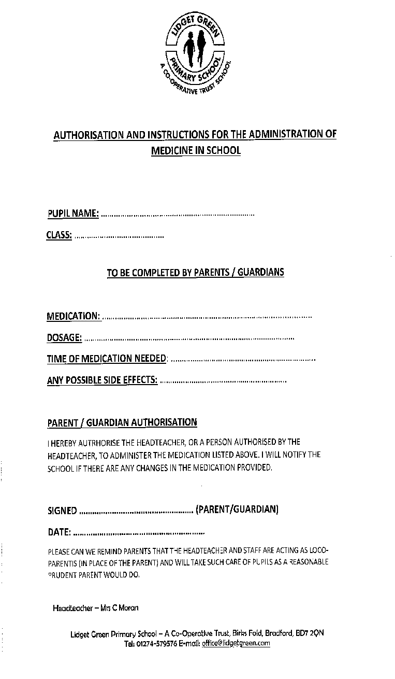Appendix 2

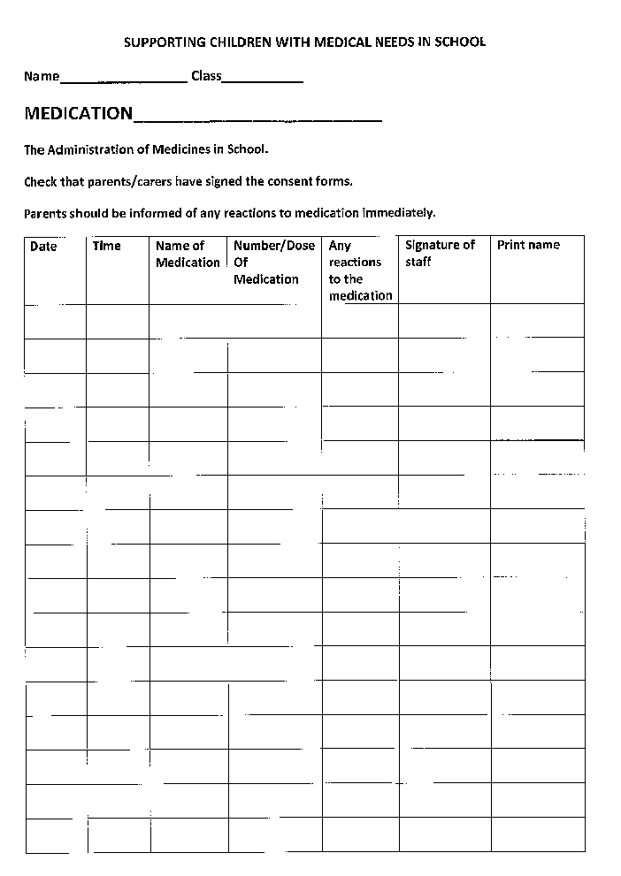

Appendix 3

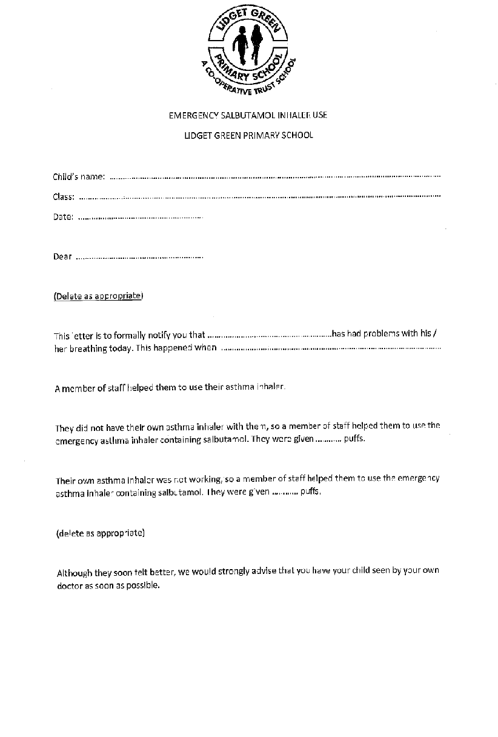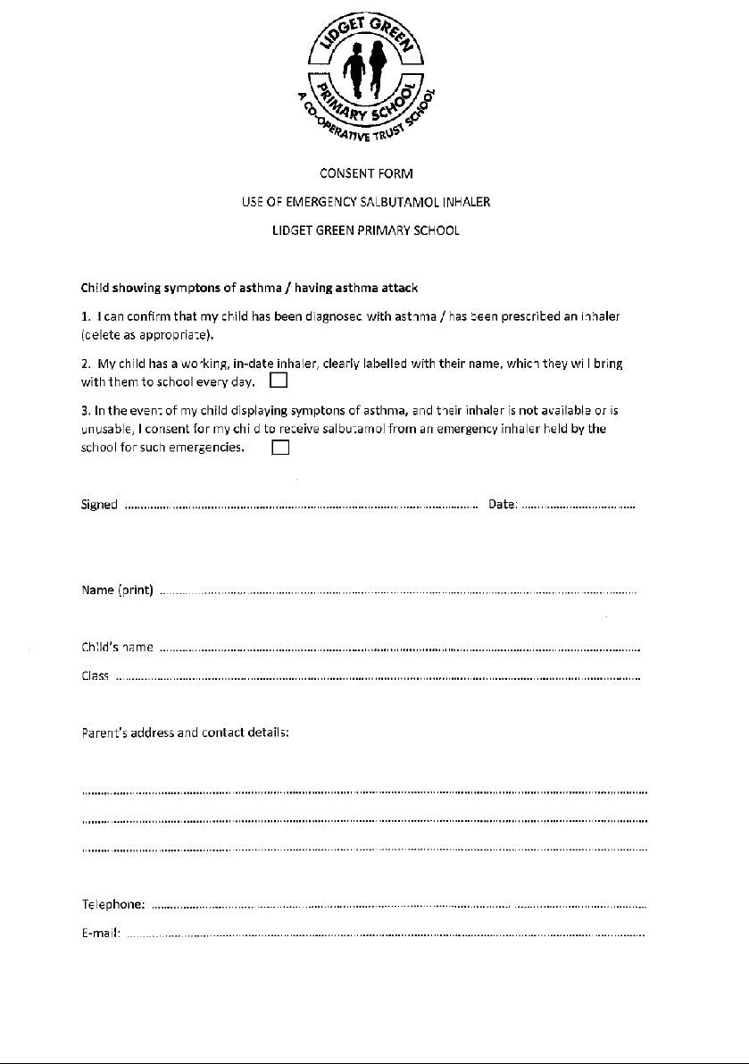
Appendix 3: Trained First Aiders in School

First Aid at Work
Name | Date of Award | Awarded by | Type of Award (Level and Category ) |  | Any additional units awarded | Expiry Date
Glenn Parkin | 9th October 2019 | Gem compliance | First Aid at work |  | Paediatric | 9th October 2022
Tamara Butterworth | 12th February 2020 | First on Scene | First Aid at Work |  | Paediatric | 11th February 2023
Tomasz Pekul | 14th December 2020 | Gem Compliance | First Aid at work |  | Paediatric | 13th December 2023
Jean Seager | 14th July 2021 | Gem Compliance | First Aid at work |  | Paediatric | 13th July 2024
Nicola Cawdry | 16th July 2021 | Gem compliance | First Aid at work |  | Paediatric | 15th July 2024

Paediatric First Aid
Saeema Atif | 16th/17th September 2019 | Gem Compliance | Paediatric L3 |  | 17th September 2022
Lisa Bland | 19th/26th^{h} September 2019 | Gem Compliance | Paediatric L3 |  | 26th September 2022
Sherrie Lake | 14th/15th October 2019 | Gem Compliance | Paediatric First Aid L3 |  | 15th October 2022
Tahira Khan | 14th/15th October 2019 | Gem Compliance | Paediatric First Aid L3 |  | 15th October 2022
Leanne Shackleton | 9th/10th March 2020 | Gem Compliance | Paediatric L3 |  | 10th March 2023
Sabia Khan | 2nd December 2020 | Gem Compliance | Paediatric L3 |  | 1st December 2023
Ikhlaq Khan | 2nd December 2020 | Gem Compliance | Paediatric L3 |  | 1st December 2023
Iffat Gazoor | 1st February 2021 | Gem Compliance | Paediatric L3 |  | 31st January 2024
Riffat Ammar | 1st February 2021 | Gem Compliance | Paediatric L3 |  | 31st January 2024
Shazia Akram | 24th March 2021 | Gem Compliance | Paediatric L3 |  | 22nd March 2024
Katarzyna Lewanczyk | 21st June 2021 | Gem Compliance | Paediatric L3 |  | 20th June 2024
Kathryn Eccles | 21st June 2021 | Gem Compliance | Paediatric L3 |  | 20th June 2024
Sana Saeed | 17th August 2021 | Gem Compliance | Paediatric L3 |  | 16th August 2024
Zarnain Rizvi | 3rd November 2021 | Gem Compliance | Paediatric L3 |  | 2nd November 2024
Laura Flowers | 15th October 2021 | Gem Compliance | Paediatric L3 |  | 14th October 2024
Sana Patel | 3rd November 2021 | Gem Compliance | Paediatric L3 |  | 2nd November 2024
Zahra Masooma | 15th October 2021 | Gem Compliance | Paediatric L3 |  | 14th October 2024
Tasmia Koser | 14th December 2021 | Gem Compliance | Paediatric Level 3 |  | 13th December 2024
Iram Iqbal | 14th December 2021 | Gem Compliance | Paediatric Level 3 |  | 13th December 2024
Murryum Arif | 9th February 2022 | Gem Compliance | Paediatric L3 |  | 8th February 2025
Tanzeela Bi | 9th February 2022 | Gem Compliance | Paediatric L3 |  | 8th February 2025
Saira Parveen |  |  | Paediatric L3
Shabana Kausser

