Reception Newsletter (September 2022)

Dear Parents,
Welcome to our first term in Reception. We hope you have all had a lovely summer and your children are excited about starting school.

Staff.
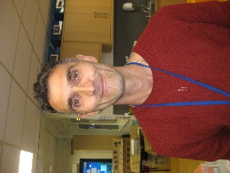

Mrs Warbrick Mr Russell
Lead Teacher (EYFS) Teacher

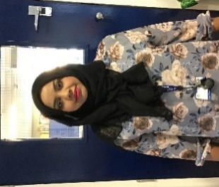

Mrs Bland Mrs Shackleton Mrs Fareed
Teaching Assistant Nursery Nurse (Mon- Thurs) Teaching Assistant (Fri)

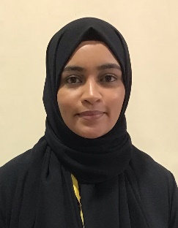

Mrs Khalifa
Support Assistant

Start and finish times.
Next week (12th September), your child will continue to come to school for either the morning or afternoon session.
Morning children should come to the classroom at 8.40am and be collected from the classroom at 11.45am.
Afternoon children should come to the classroom at 12.45pm and be collected from the classroom at 3.10pm.
The following week (19th September), all children will start at 8.40am and finish at 3.10pm.
If you have children in other year groups, please bring and collect Reception children first. It is important that they are here on time as we will be starting to teach Phonics from next week.

Coats.
Now that the weather is likely to become chillier and more showery, please could we remind you to send your child with a coat every day. Children in Reception enjoy playing outside even if it is a bit rainy, so a coat is essential.
Please make sure that all coats and sweatshirts are named.

Book bags.
Children should bring their book bag to school every day. They do not need to bring any other bags or pencil cases. Please ensure that book bags are named.

Water bottles.
Please send your child to school with a named water bottle. Please do not put them into book bags as they often leak and spoil the books.

Class Dojo.
You will already have received an invitation to join Class Dojo. Please do this as soon as possible as it is the main way that school can send messages to parents, and you can also message your child’s teacher.

We have been very pleased with the way the children have settled into their reception classes in their first week and thank you for your support,

The Reception Staff Team

