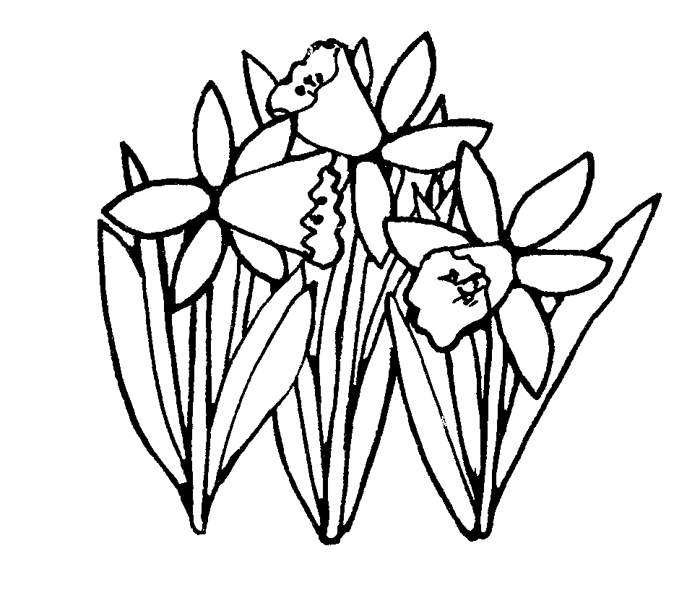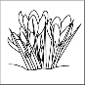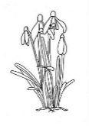

Autumn Term Year 2 Class Newsletter

I hope you all had a wonderful summer and are looking forward to the exciting year ahead. The Year 2 Team have been super impressed with the way your children have settled back into school life and adapted to their new routines. We can’t wait to see how the year unfolds.

The following information will tell you some of the things the children will be learning in Year 2. If you have any issues or concerns, please contact us via class dojo, speak to us at home time or make an appointment through the school office. We are looking forward to a very positive and rewarding year where we can all work together to help your child to reach their full potential.

**Dates for your diary:**

Wednesday 21st October School closes for Half Term Break

Tuesday 1st November School re-opens

Wednesday 2nd November Parent Consultation Evening

Monday 7th November Parent Consultation Evening

|  |  |  |
| --- | --- | --- |
| **Curriculum Area** | **Focus for learning** | **How you can help at home** |
| Pen Clip Art**English**  http://images.clipartpanda.com/english-clipart-SecondaryBooks.gif | The children will be learning about polar bears and penguins this half term. They will read a range of non-fiction and fiction reading texts. The children will be exploring how to write questions and statements with a focus on basic punctuation. | Encourage your child to read aloud to you at home. Make sure the books are challenging enough and provide them with new experiences.  Continue to practise the weekly spellings at home with your child. |
| **Maths**  Image result for maths b&w | The children will be looking at basic place value and addition and subtraction of one and two-digit numbers.  The children will also be looking at multiplication and division and building on their basic number skills. | Help your child to practise their 2 and 10 Times Tables  Help your child to practise simple counting to 100 and back.  Create simple sums to practice adding and taking away. |
| Image result for scienceclip art b&wImage result for BIOLOGY clip art b&wMicroscope 20clipart | Clipart library - Free Clipart ImagesRelated image**Science**Image result for scienceclip art b&w | The children will be learning about animals and their habitats and their basic needs to survive. | Talk to your children about the work they have been doing in class.  Find out about about penguins and Antarctica using books, TV or the Internet. |
| **R.E.** | The children will be exploring the beliefs and practices of religions such as Islam and Christianity. They will learn about how people welcome babies into the world and why promises are important. | Discuss with your child what they have learnt about different beliefs and religious practices. |
| **Image result for fitness clip art b&wP.E.**  **Image result for fitness clip art b&w** | The children will be learning how to play football and develop fundamental skills such as balancing, throwing and catching this half term. | Please check that your child comes in the correct PE kit.  Discuss with your child what skills they have learnt in PE. |
| **Topic**  Related imageImage result for painting clipart b&w -zoneImage result for scissors clipart b&w -zoneImage result for hammer clipart b&w -zoneImage result for history  clipart b&w -zone  **(History, Geography)** | This half term we have a Geography focus so we will be looking at the world map, identifying continents and oceans. We will also be looking at the seas surrounding the UK, countries and capital cities of the UK. | Ask your child about what they have learnt. Encourage them to look at maps and see if they can identify the continents and oceans. |
| **Art/DT**  Information And Facts That Will Help You With Crafts And Art | The children will be exploring different media and materials. They will be using paint, wax crayons, water colours. | Discuss with children the new techniques and methods they have learnt in lessons. What can they tell you about the artists and art forms? |
| **Computing**  Image result for computer coding clipart b&w -zone | Children will be learning about internet safety. They will learn how to use technology purposefully to create, organise, store, manipulate and retrieve digital content. | Discuss with children the new things they have learnt about computing. Practice the skills at home using Purple mash. |