Year 5 Newsletter - Autumn Term 2022
Welcome to Year 5
Welcome back to a new school year at Lidget Green Primary School. We are looking forward to working with you to support your child/children in their learning journey this academic year. Our topic for the first half term is a History topic, where we will be looking at ‘Conflict’ throughout history with a focus on World War 2. Our class text links into this topic and is called ‘Friend or Foe’ by Michael Morpurgo.
Uniform
Children must wear the correct uniform in school, including plain dark shoes – brightly coloured trainers are not allowed Your child will need to come to school in the correct PE Uniform on the days they have PE. This is a red polo shirt and Navy Blue jogging top, bottoms and dark trainers.
Class Dojo
We will continue to use Class Dojo as our reward system and you can access this by signing up to the Class Dojo App. You will receive a letter with instructions on how to do this if you haven’t already signed up. Class Dojo also gives you the opportunity to send and receive messages to the class teacher

What happens on each day?
Day | Activity
Monday
Tuesday | - P.E (5S 5N 5C)
Wednesday | - Hand in Homework*
Thursday | - P.E. (5N, 5C 5S)  - Times table test
Friday | - Spelling test  - Homework given out*
*Homework will be given once we are settled into our new routines. In the meantime, please ensure your child reads regularly and practises times tables and spellings.
Home Reading
Home reading books are taken home each night and will be changed weekly. It is a very important part of your child’s learning so please ensure your child is reading daily where possible.

 |  |  |  | 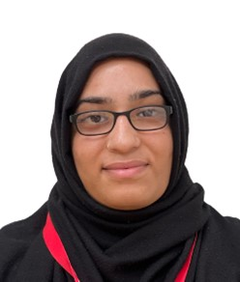
Mrs Clayton  Teacher, 5C | Miss Noor  Teacher 5N | Miss Sale  Teacher 5C | Mrs Mir  Teaching Assistant | Mrs Zaman  Teaching Assisstant
Dates for your diary:
School closes for Half Term: Friday 21st October 2022
School re-opens: Tuesday 2nd November 2022
Parent consultation meetings: Wednesday 2nd November 2022
Monday 7th November 2022
School closes for the Christmas Holiday Friday 16th December 2022

