A Vision for Handwriting and Presentation

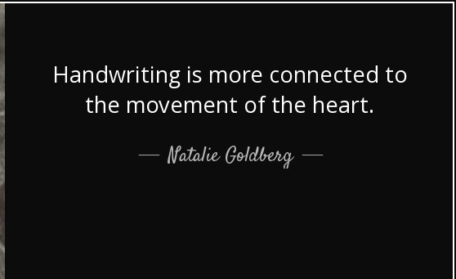
When communicating ideas in writing it is important that pupil use a handwriting style which is neat and legible. The importance of handwriting should not be under-estimated. It is vital that pupils can write fluently, comfortably and legibly, with increasing speed, as it is a skill needed in many curriculum areas and the future. Pupil’s self-esteem is also heightened when they are able to take pride in their handwriting.
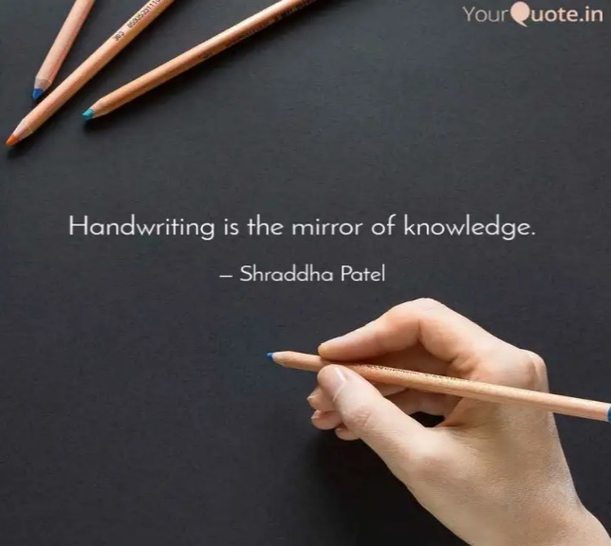
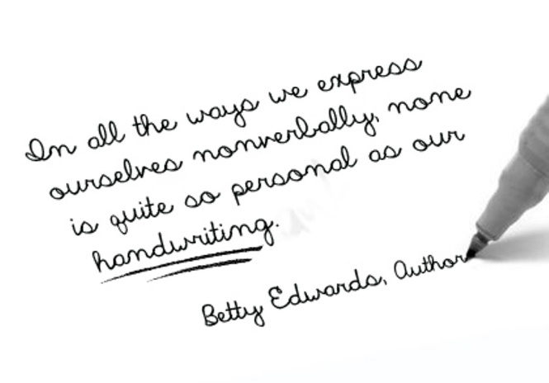

Handwriting and Presentation Policy
Lidget Green Primary School

Handwriting, as in many other skills develops at different rates, so it is important that all staff have a clear understanding of the progression of skills and can remedy errors efficiently. It is our aim to encourage the progression and development of each child’s handwriting throughout the school into a fluent, legible and individual style that can be adapted for a range of purposes and will support their spelling and composition.
Intent
​Handwriting is a skill which, like reading and spelling, affects written communication across the curriculum. Pupil must be able to write with ease, speed and legibility. Cursive handwriting teaches pupils to join letters and words as a series of flowing movements and patterns. The development of this fluid style when mastered allows pupil to apply their energy into the content of their writing as opposed to the formation of the letters themselves. Handwriting skills are taught regularly and systematically throughout the school.
At Lidget Green Primary School our aims in teaching handwriting are:
- To enable pupil to write in a consistent, well presented and legible format.
- To have a consistent approach across Foundation Stage, Key Stage 1 and 2 when teaching handwriting.
- To make sure all pupils know the difference between lower and upper-case letters.
- To ensure the skills taught at Key Stage 1 continue to develop throughout Key Stage 2.
- To adopt a consistent approach towards handwriting by all adults when writing in pupil’s books, on the whiteboard or on displays / resources.
It is our aim to encourage the progression and development of each child’s handwriting throughout the school into a fluent, legible and individual style that can be adapted for a range of purposes and will support their spelling and composition.
In keeping the appearance of work in books of high quality, it is important that all pupils within the school are supported to develop clear and neat handwriting. This should be expected and applied in all subject areas. It is important that staff understand that handwriting is subjective to each and every individual but also that we should expect a consistent approach to the teaching of handwriting throughout the school.

Implementation
The most widely recommended handwriting style is called continuous cursive. It’s most important feature is that each letter is formed without taking the pencil off the paper – and consequently, each word is formed in one, flowing movement. The key advantages to this system are:
- By making each letter in one movement, pupil’s hands develop a ‘physical memory’ of it, making it easier to produce the correct shape
- Because letters and words flow from left to right, pupil are less likely to reverse letters which are typically difficult (like b/d or p/q)
- There is a clearer distinction between capital letters and lower case
- The continuous flow of writing ultimately improves speed and spelling
In teaching and supporting pupils to have neat handwriting, we use the following expectations. These are set out within four distinct steps, which we expect pupils to reach at certain points. However, where a child may need additional support to embed or develop skills, the time taken to achieve these steps may be adjusted.
Step 1 – Early Years and the start of Year 1

Cursive un-joined letters
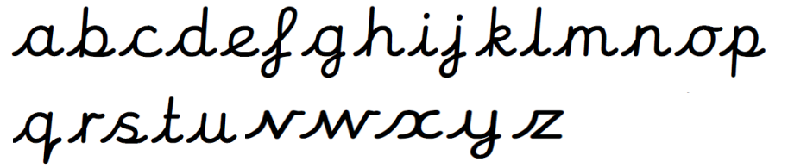
In the Foundation Stage pupils will be encouraged to develop gross motor control through the use of large equipment for mark making such as big chalks, paint brushes, finger paints, shaving foam etc. They will develop their fine motor skills and use a range of mark making tools such as pencils, pens and crayons. They will be encouraged to talk about shapes and movement. They will practise the main handwriting movements for the three basic letter shapes c, l and r. As the pupil progresses they will be taught to form letters correctly starting using the Essential Letters and Sounds guidance on letter formation.
Letter formation is taught alongside phonic development. Our aim is that by the end of foundation stage all pupils hold a pencil correctly and form all letters and numbers correctly. Errors in pencil grip and letter formation will be immediately addressed, modelled and corrected. Initially, Foundation Stage pupils will use unlined paper as the focus is correct formation rather than size or positioning. Pupils will be taught unjoined letter formations, using the rhymes and graphemes from the Essential Letters and Sounds scheme. This will be taught within phonics sessions and will be revisited as part of teacher-led sessions and during child-initiated learning. As pupils move through Reception and into Year 1, a greater level of expectation will be paid to ensuring that all pupils are using these formations in all of their written work.
Step 2 – Mid-Year 1 and Year 2
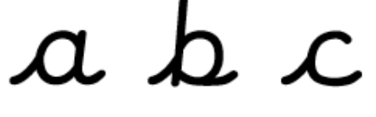
Pupils will continue to be taught letter formations and will have lessons each week where this will be specifically taught but also to begin to include initial leading joins, to support pupils in beginning to join their writing. All pupils will have handwriting books for this. Our aim is that by the end of Year 1 pupils will be forming all letters correctly.

In Year 2, adults will model cursive writing from the beginning of the year. The pupils will be encouraged to continue the development of basic joins which they should transfer into all their independent writing. They will also continue to link their handwriting to their phonic development as they learn to write new sounds using a cursive writing style.
In English and some subjects which anticipate longer writing, pupils in Key Stage 1 will have books which provide handwriting lines for them to use. There will also be use of the same handwriting style, where possible, from staff to model expectations throughout lessons in addition to the handwriting font being used in worksheets and interactive whiteboard slides. It is, however, helpful for pupils to begin to access other fonts and typefaces and therefore a mix will be expected.

Step 3 – Year 3 onwards
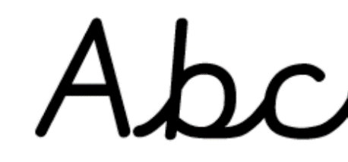
In Year 3 pupils will continue to develop their use of cursive handwriting building upon the skills they have developed in Key stage 1.
Books in all subjects will have lines, however where pupils still have not secured ascenders or descenders, they will be able to use handwriting guide lines. Joined cursive script will be used by staff to model expectations throughout lessons in addition to the handwriting font being used in some worksheets and interactive whiteboard slides (XCCW Joined). It is, however, helpful for pupils to begin to access other fonts and typefaces and therefore a mix will be expected. As pupils show greater accuracy with this in Years 3 and 4, teachers may request that they use a pen. This decision will be made by the English subject lead.

Step 4 – When pupils have an established handwriting style
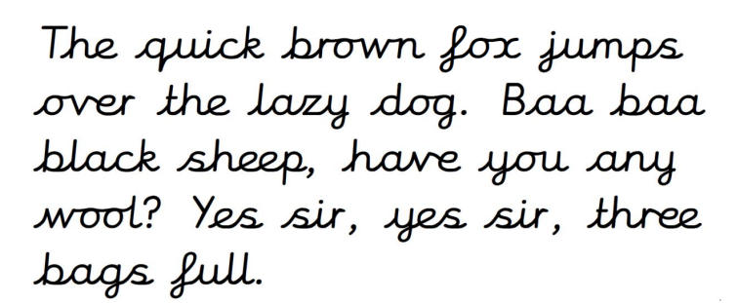
In Years 5 and 6 pupil cursive handwriting will be expected, where possible, in all areas of writing, however we recognise that some pupils will have alternative handwriting styles of similar neatness. In this case, we would expect to see neat, cursive script being used in all final draft work.

If any child is not on track to reach these expectations, they will receive additional support through small group intervention groups.

Provision for left-handed children
At least 10% of the population are left-handed, the majority of whom are boys. All teachers are aware of the specific needs of left-handed pupils and make appropriate provision:
- paper should be positioned to the left for right handed pupils and to the right for left handed pupils and slanted to suit the individual in either case;
- pencils should not be held too close to the point as this can interrupt pupils’ line of vision;
- pupils should be positioned so that they can place their paper to their left side;
- left-handed pupils should sit to the left of a right-handed child so that they are not competing for space;
- extra practice with left-to-right exercises may well be necessary before pupils write left-to-right automatically.
Handwriting Equipment
Pupil will use line sizes appropriate to their stage in writing. During handwriting sessions specific handwriting paper with 3 lines may be used. Pupil will also practise using the same sized lines as their other curriculum books so that pupil skills are transferable and that the same expectation of handwriting in set across all writing.
Pupil should use a sharp HB pencil for all handwriting initially. When in KS2, teachers may assess that pupil are competent at joined handwriting, if so, they should be allowed to use a blue handwriting pen which will be provided by the English lead along with a Handwriting License. In some cases, depending on the specific needs of individuals, a pupil may require the use of pencil grips or pens with a specific grip.
Teaching of Handwriting

Handwriting is to be taught regularly through short, focused sessions and may be linked with spelling, grammar or phonics objectives. Teaching generally occurs outside English lessons, although shared and guided writing provides additional opportunities for the modelling and monitoring of handwriting.

Assessment
A uniformed handwriting style should be consistent throughout the school; this will be evident on display boards and monitored through lesson observations and book scrutiny.
Level expected at the end of EYFS.
Pupils should be taught to:
Literacy – Writing ELG
- Write recognisable letters, most of which are correctly formed
- Spell words by identifying sounds in them and representing the sounds with a letter or letters
- Write simple phrases and sentences that can be read by others.
Physical Development – Fine Motor Skills
- Hold a pencil effectively in preparation for fluent writing – using the tripod grip in almost all cases
- Use a range of small tools, including scissors, paint brushes and cutlery
- Begin to show accuracy and care when drawing.
Key Stage 1 National Curriculum Expectations
Pupils should be taught to:
• sit correctly at a table, holding a pencil comfortably and correctly.
• begin to form lower case letters in the correct direction, starting and finishing in the right place. • form capital letters.
• form digits 0-9.
• understand which letters belong to which handwriting ‘families’ (i.e. letters that are formed in similar ways) and to practise these.
• form lower case letters of the correct size relative to one another.
• start using some of the diagonal and horizontal strokes needed to join letters and understand which letters, when adjacent to one another, are best left unjoined.
• write capital letters and digits of the correct size, orientation and relationship to one another and to lower case letters.
• use spacing between words that reflects the size of the letters.

Key Stage 2 National Curriculum Expectations
Pupils should be taught to:
- use the diagonal and horizontal strokes that are needed to join letters and understand which letters, when adjacent to one another, are best left unjoined.
- increase the legibility, consistency and quality of their handwriting for example, by ensuring that the down strokes of letters are parallel and equidistant; that lines of writing are spaced sufficiently so that the ascenders and descenders of letters do not touch.
- write legibly, fluently and with increasing speed by: choosing which shape of a letter to use when given choices and deciding whether or not to join specific letters: choosing the writing implement that is best suited for a task.
Marking and Feedback
We emphasise constructive feedback. In our feedback policy we have clear systems for feedback of pupil’s work which is adhered to throughout our handwriting sessions. In handwriting sessions and during independent work it is important that incorrect pencil grip and incorrect letter formation are identified and corrected at the point it occurs.
- See Marking and Feedback Policy
Impact
Handwriting is a skill which affects written communication across the curriculum. Our aim is that pupils are able to write with ease, speed and legibility.
By year 6 pupil will use cursive handwriting using flowing movements and patterns. This handwriting should be demonstrated in all writing across the curriculum. Writing should be fluid in style to allow pupil to apply their energy into the content of their writing as opposed to the formation of the letters themselves.

Naheed Akhtar (Assistant Head/English Leader)
Date: February 2023
Review date: September 2023

