A Vision for Writing

At Lidget Primary School, we recognise English skills underpin all elements of the school curriculum, and English in spoken and written form is the foundation for all our learning. It is integral to all aspects of life, and with this in mind, we aspire all our pupil to adopt a healthy and enthusiastic attitude towards writing which will stay with them beyond their primary years and for our pupils to communicate effectively, coherently and creatively. Writing enables pupils to impart their thoughts and opinions, express their emotions and share experiences and explanations; thus, enabling their communication skills to grow in order to become effective communicators within society and be literate adults in the 21st Century.
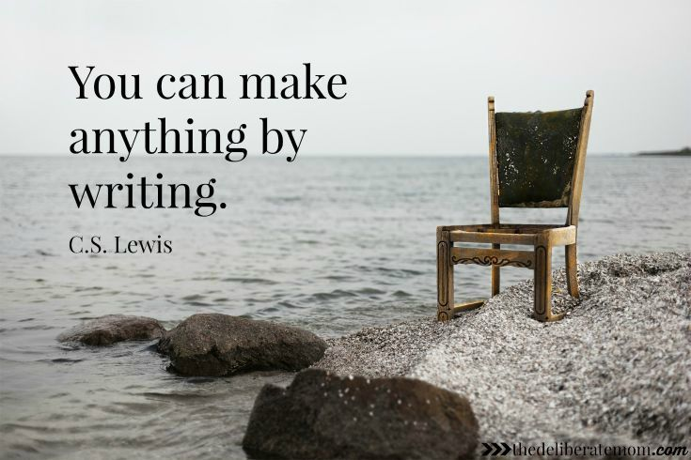

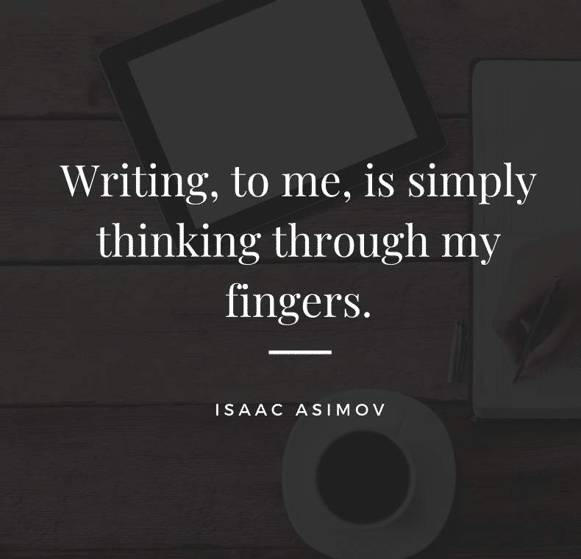

Writing Policy
Lidget Green Primary School

This policy is for the staff in our school. It aims to set out:
- Our approach to teaching, monitoring and assessing English and literacy knowledge and skills
- How we will make sure our provision for the teaching of English and literacy is of consistently high quality
This policy reflects the requirements and expectations set out in:
- The National Curriculum programmes of study for English

Intent
​At Lidget Green Primary School, writing is a crucial part of our curriculum. All pupils from Foundation Stage to Year 6 are provided with many opportunities to develop and apply their writing skills across the curriculum.
Our intention is for our pupils to be able to plan, revise and evaluate their writing. To be able to do this effectively, pupils will focus on developing effective transcription and effective composition. They will also develop an awareness of the audience, purpose and context, and an increasingly wide knowledge of vocabulary and grammar. We intend for pupils to leave school being able to use fluent, legible and speedy handwriting.

At Lidget Green Primary School we believe that:

• Speaking and listening with confidence are significant factors in developing effective writing;
• Reading and writing are closely connected and mutually supportive; we read as writers and write as readers;
• Writing is a craft and most pupil learn best through their own writing, rather than through exercises out of context;
• Writing is best framed within recognisable text-types or genres;
• Writing should be designed to meet the needs of real or imagined audiences;
• Writing tasks should be prepared through preliminary talk and adults should model writing for their pupils;
• Pupils should be given the opportunity to collaborate with other pupils both to compose and to revise their writing;
• Writing skills can be improved through reflection and self-editing is encouraged;
• Pupils should be closely involved in assessing their own development as writers;
• More effective writing is dependent upon increasingly informed grammatical and linguistic choices;
• The adult’s response to the pupil’s composition (e.g. praising aspects of the content) is crucial in developing confidence and motivation;
• The skills of transcription (ie handwriting, punctuation and spelling) must be thoroughly planned for and taught;
• ICT can be used as an inspiring stimulus for writing and to enable pupils to author their own multimedia texts.

Implementation
Our school provides daily English lessons that are progressive and support skill development. Pupils are given a range of writing opportunities including the use of paired, group and independent writing tasks. This is developed across Key Stages, so that the pupils learn to respond appropriately and supportively to each other. In our teaching of writing, we aim for all pupils to:
• Appreciate that writing is a universal method of communication;
• View writing as a process over which they have control;
• Enjoy playing with language and write for pleasure;
• Write appropriately for specific real or imaginary audiences;
• Write for a variety of purposes;
• Make judgements about the tone, style, format and vocabulary appropriate to the writing’s purpose, audience and genre;
• Write clearly, legibly and accurately with attention to punctuation, spelling and grammar;
• Recognise that drafting, incorporating significant revision into their writing and proof-reading are integral parts of the writing process;
• Achieve independent writing of a high quality

Early Years Foundation Stage
Writing is taught in the Foundation Stage through every area of learning. Pupil’s early mark making is valued and pupil are encouraged to bring writing into their play and to give meaning to their marks. They are taught, once ready, to form letters correctly, initially the letters in their names, then moving on to other letters which are taught in specific groups according to their orientation. In Reception, or sooner if they are ready, pupils are taught to use and apply their phonic knowledge independently when writing, giving plausible spellings for new words. Opportunities for writing in the foundation stage are available in every area of provision (indoors and out).

Writing in KS1 and KS2
In English lessons across both Key Stages, teachers plan a sequence of lessons that explore quality texts and give pupils the opportunity to practice writing and reading skills. Teachers model these skills on regular basis and planning, editing, publishing and ICT based tasks can be planned in as part of the teaching sequence.

Planning Guidance
Through our English planning we aim to consolidate three key features of writing. These are:
• Phonics, Spelling and Vocabulary (Word Level)
• Sentence Structure, Grammar and Punctuation (Sentence Level)
• Text, Structure and Organisation (Text Level)

The Teaching Sequence
These key features are addressed through a consistent approach to the teaching of English units. Teachers follow the teaching sequence of:
• Planning- pupils gather information, activate prior knowledge, and read exemplar texts to identify key features and consider the writing style.
• Drafting- pupils write down key ideas and set out a structure for the writing
• Revising- pupils make changes in light of feedback and self-evaluation
• Editing- pupils make changes to ensure writing is accurate and coherent
• Publishing- pupils publish writing and are ready to share

Short Writing
Writing is not left until the writing phase. Writing skills need to be constantly practised and revisited throughout the reading and gathering content phases. Outcomes should be linked to a specific learning objective e.g. LO: To infer character thoughts and feelings – Outcome: diary.
Examples of short writing opportunities include:
- diary entries
- character profile
- dialogue exchange
- fact file
- letter
- narrative
- book review

Shared writing and modelled writing
Shared writing is a whole class activity where the teacher models the writing of a text using a pre-prepared model text. In shared writing, the pupil will contribute to the text by suggesting words or sentences to be used when asked to; they can be critical partners for the teacher. The teacher demonstrates how to write and explains the decisions made. S/he will model thinking, rehearsing sentences, writing and re-reading, constantly generating words and ideas. Across the key stages, teachers will focus on the purpose, audience, level of formality, structure and organisation of the text. A particular aspect of spelling or grammar and punctuation work provides an additional focus depending on the objectives and targets being worked on at that time.

Guided writing
Guided writing is the mid-way point between independent and shared writing. It is the teacher or teaching assistant guiding a group of pupils through a piece of writing, helping and supporting them. This is extremely focused and addresses the needs of a specific group, allowing the adult to give immediate feedback on the successes and areas for development.

Independent writing
In independent writing, the pupil may have received input from the teacher in shared or modelled writing but the child is left to his/her own devices when the writing takes place. At the end of a unit of work, all pupil will have completed their own piece of independent writing and publish it. This will usually be written into their writing portfolios. Independent writing is supported through the use of dictionaries, word banks, spell checkers, thesauruses, writing frames or plans.

We endeavour to provide opportunities for pupils to write in a range of context across the curriculum. Planning these writing opportunities help us to develop confident, enthusiastic writers who can express themselves in a variety of different styles and across a variety of contexts. This provides our pupils with regular opportunities to write for a range of purposes and audiences. Writing tasks are specific and meaningful, and often meet a purpose to engage pupils and to illustrate how their writing skills can be applied to real life contexts.
Oracy- Dialogic Talk
Spoken language underpins the development of reading and writing here at Lidget Green Primary. As a school we wholeheartedly believe high quality writing arises from a sea of talk and every opportunity has been provided for pupils to participate in discussion activities. The quality and variety of language that pupils hear and speak are vital for developing their vocabulary and grammar and their understanding for reading and writing. All teachers will therefore ensure the continual development of pupils’ confidence and competence in spoken language and listening skills. Pupils will develop a capacity to explain their understanding of books and other reading, and to prepare their ideas before they write.
Further information can be found in the Dialogic Talk policy.
Spelling, vocabulary, grammar and punctuation
Opportunities for teachers to enhance pupils’ vocabulary should arise naturally through the reading and writing lessons. As pupils’ vocabulary increases, teachers will show pupils how to understand the relationships between words, how to understand nuances in meaning, and how to develop their understanding of, and ability to use, figurative language. They should also teach pupils how to work out and clarify the meanings of unknown words and words with more than one meaning.
Pupils should be taught to control their speaking and writing consciously and to use Standard English. They should be taught to use the elements of spelling, grammar, punctuation and how to use the language to describe language. This is not intended to constrain or restrict teachers’ creativity, but simply to provide the structure on which they can construct exciting lessons. Throughout the programmes of study, teachers should teach pupils the vocabulary they need to discuss their reading, writing and spoken language. It is important that pupils learn the correct grammatical terms in English and that these terms are integrated within teaching.
Differentiation
“What a child can do today with assistance, she will be able to do by herself tomorrow.” Lev S. Vygotsky
Lidget Green Primary aims to provide for all pupils so that they achieve as highly as they can in Writing, according to their individual abilities. By means of on-going assessment, teachers can highlight a difficulty or identify which individuals or groups are under achieving and for what reason/s and will take steps to improve their attainment. Pupils who are identified as greater depth throughout all areas of the curriculum will also be identified and suitable challenges provided within daily teaching. Pupils, who are underperforming, will be part of the class teacher’s focus.
Equal Opportunities
At Lidget Green Primary, we ensure that all pupils are provided with the same learning opportunities whatever their social class, gender, culture, race, disability or learning difficulties. All pupils will have Quality First Teaching. Any pupils with identified SEND or identified as needing additional support will have work additional to and different from their peers in order to access the curriculum dependent upon their needs. As well as this, our school offers a demanding and varied curriculum, providing pupil with a range of opportunities in order for them to reach their full potential and consistently achieve highly from their starting points.
Links with Other Subjects
Teachers should seek to take advantage of opportunities for writing to make cross-curricular links where relevant. Teachers should plan for pupils to practise and apply the skills, knowledge and understanding acquired through writing lessons to other areas of the curriculum using the principles of writing document to ensure the consistency and quality of writing remains the same.
Handwriting
- Please see Handwriting policy

Assessment
Assessment for learning strategies are used on a daily basis. These show the pupils’ progress, any areas of strength or weakness which can then be addressed in teachers’ planning. Formative assessment of learning is completed termly using assessment against the school Writing Progression map. Following the teaching of a unit of work pupils frequently complete an independent writing piece, which is assessed against our writing criteria. Analysis of the data is incorporated into teachers planning so pupils’ needs can be addressed. Moderation of teacher assessment is also completed termly in order to ensure that judgements are accurate. Data is analysed to ensure that all pupils are making at least expected progress. These results are monitored by subject leaders and SLT and reported to Governors. Pupils who are not on track are identified for intervention/target teaching.
Expectations
By the end of the Foundation stage, we expect most of our pupils to have achieved the Early Learning Goals in line with at least national average. By the end of key stage 1, the performance of pupils should be in the range of ‘working at’ age related expectations with some pupils achieving ‘greater depth’ By the end of key stage 2, the performance of the pupils should be in the range of ‘working at’ age related expectations with some achieving ‘greater depth’.
Marking and Feedback
Marking and feedback will clearly explain to pupils what they’re doing well, and what they need to do next to continue to improve upon their work. It will be given verbally, in pupils’ books or via your digital learning platform- Google Classroom.
- See Marking and Feedback Policy
Moderation
Moderation is a crucial part of teacher assessment. It allows teachers to benchmark their judgements, while helping to ensure that standards are consistent and outcomes are reliable. Lidget Green Primary will ensure that their teacher assessment judgements are moderated internally and, where possible, with other schools. This will quality-assure the schools’ judgements and provide a valuable opportunity for professional development. We ensure that teachers moderate pupils’ writing on a termly basis both internally within year groups and phases as well as externally in SATS year groups, 2 and 6.
Role of the teacher
- Ensure lesson covers all English National Curriculum objectives
- A high level of presentation is expected across all subjects when writing
- Guided/shared writing is planned for and delivered
- Writing is published at least once every half-term in Writing Portfolios
- Skills taught in English are reinforced and embedded throughout all other areas of learning; this is evidenced in all work
- English to be taught every day for 1 hour.
- Punctuation and grammar should be embedded in all English teaching and should be evident within planning.
- Spelling lessons are delivered every week.

Role of the English Lead

- Give precedence to enhancements for the teaching and learning of writing across the school and add to the school improvement plan, in consultation with the Headteacher and Governing Body, driving forward the improvement of writing teaching and progress and achievement of learners.
- Ensure that the school’s senior leadership team and governors are kept up-to-date about the quality of teaching and learning in writing and the implementation of the writing sequences.
- Work in close partnership with the school’s senior leaders to ensure the learning needs of all pupils in writing are met effectively as well as analyse assessment data in order to plan whole school improvements in writing or specifically within a year group/phase.
- Monitor pupil’s progress and monitor and evaluate writing provision in the school by conducting regular work scrutinies, learning walks, deep dives and pupil voices as well as analysing whole school moderations.
- Keep colleagues informed of any changes in practice, providing training and/or information when appropriate.
- Ensure that resources are appropriate, available and of good quality.

Impact
As we believe that English skills are vital to the development of pupils so they are prepared for their future life. The impact of our English curriculum goes beyond the result of statutory assessments. Pupil will make good progress from their own personal starting points. By the end of Year Six they will be able to write clearly and accurately and adapt their language and style in and for a range of contexts, purposes and audiences. Our pupil will acquire a wide vocabulary and have a strong command of the written word. Most importantly, they will develop a love of writing and be well equipped for the rest of their education.
Naheed Akhtar (Assistant Head/English Leader)
Date: February 2023
Review date: September 2024

