Lidget Green Primary School Pupil premium strategy statement

This statement details our school’s use of pupil premium funding (and recovery premium for 2023 to 2024) to help improve the attainment of our disadvantaged pupils.

It outlines our pupil premium strategy, how we intend to spend the funding in this academic year and the effect that last year’s spending of pupil premium had within our school.

School overview
Detail | Data
School name | Lidget Green Primary School
Number of pupils in school | 553
Proportion (%) of pupil premium eligible pupils | 174 (31.5%)
Academic year/years that our current pupil premium strategy plan covers (3 year plans are recommended) | 2023-2024  2024-2025  2025-2026
Date this statement was published | December 2023
Date on which it will be reviewed | December 2024
Statement authorised by | Louise Woffendin Headteacher
Pupil premium strategic lead | Louise Woffendin
Governor / Trustee lead | Dierdre Bailey
Funding overview
Detail | Amount
Pupil premium funding allocation this academic year | £ 240,075
Recovery premium funding allocation this academic year | £ 24,505
Pupil premium funding carried forward from previous years (enter £0 if not applicable) | £ 0
Total budget for this academic year  If your school is an academy in a trust that pools this funding, state the amount available to your school this academic year | £ 264,580

Part A: Pupil premium strategy plan

Statement of intent
- At Lidget Green Primary School, we have high aspirations and ambitions for our children and we believe that all learners should be able to reach their full potential.
- We strongly believe that reaching your potential is not about where you come from, but instead, about developing the necessary skills and values required to succeed in life.
- Our pupils in receipt of the Pupil Premium Funding face specific barriers to reaching their full potential. At Lidget Green Primary School, we are determined to provide the support and guidance they need to help them overcome these barriers.
- In addition to this, we aim to provide them with access to a variety of exciting opportunities and a rich and varied curriculum.

Our ultimate objectives are:
- To narrow the attainment gap between disadvantaged and non-disadvantaged pupils.
- For all disadvantaged pupils in school to make or exceed nationally expected progress rates.
- To provide a whole school approach to support vulnerable pupils' and their families emotional and mental health.
- To enrich pupils' life experiences and opportunities by providing a bespoke, inclusive curriculum which meets the needs of all pupils.
The key principles of our pupil premium strategy is to promote inclusive practice throughout school, to correctly identify barriers to learning for pupils and to use school based solutions to remove those barriers.

Challenges
This details the key challenges to achievement that we have identified among our disadvantaged pupils.
Challenge number | Detail of challenge
1 | EYFS and KS1 disadvantaged pupils achieve significantly below the national average in reading,writing and maths.
2 | Pupils and their families have social & emotional difficulties, including medical and mental health issues and often have lower aspirations.
3 | - Pupil Premium pupils have lower attendance and are more persistently absent from school than Non-Pupil Premium pupils. Currently disadvantaged pupil’s overall attendance is 91.9% compared with 95% non- disadvantaged pupils. PA of disadvantaged pupils is 29.2% compared to non-disadvantaged pupils which is 15.7%. Poor punctuality is an additional barrier.
4 | Lack of cultural capital and wider experiences outside of the home impending ability to contextualise learning
5 | Poor language skills on entry to school.

Intended outcomes
This explains the outcomes we are aiming for by the end of our current strategy plan, and how we will measure whether they have been achieved.
Intended outcome | Success criteria
Disadvantaged pupils in EYFS, KS1 and Year 3  will make accelerated progress and ‘catch up’ or  exceed prior attainment standards. Children who  have fallen behind receive targeted high-quality  intervention. | Summer data will show that between 95-  100% pupils will have made at least expected progress from the previous summer.  In KS1, the gap in attainment in reading, writing and maths between disadvantaged and non-disadvantaged pupils will decrease. .  End of summer data will also show that 10-  20% of disadvantaged pupils will have made accelerated progress.  Analysis of interventions will  show that they have had a positive impact  on disadvantaged pupil’s learning and this  has accelerated their learning.
Disadvantaged pupils in KS2 continue to do as  well as if not better than non-pupil premium  pupils and they will make accelerated rates of  progress. | Summer data will show that between 95-  100% pupils will have made at least  expected progress from the previous  summer.  Pupil premium pupils at the end of KS2 will  continue to make better progress than non-  pupil premium pupils or at least as good as.  Summer data will also show that 10-20% of  disadvantaged pupils will have made  accelerated progress.  Analysis of interventions and ‘catch up’ will  show that they have had a positive impact  on disadvantaged pupil’s learning and this  has accelerated their learning.
Pupils and families with identified social,  emotional or health needs are well supported in  school so that the needs are removed or  alleviated.  Pupils from disadvantaged backgrounds have  high aspirations for themselves. | There is a whole school approach to emotional wellbeing and mental health. Headteacher, SLT SENDCo, Inclusion Manager, pastoral team, class teachers and TLA’s identify and support families and children to alleviate barriers to learning.  SENDCO completes the Senior  Mental Health lead training.  The school works very closely and in partnership with the MHST. There is impact evidence of the work they have done with pupils, families, staff and any external referrals made to relevant support agencies are  swiftly carried out to ensure pupils and  families receive the support they require.  Interventions for specific pupils are  identified and they have a positive impact  on pupil’s social, emotional or health  needs. This leads to them making at least  expected progress with their learning.  RSE, Mental Health and Well-Being  strategies are embedded and taught well  throughout the curriculum.  School achieves ‘The Healthy Minds  Chartermark’.
The gap between Pupil Premium and Non-Pupil Premium pupils’ attendance will diminish. | Whole school approach to attendance and punctuality has been embedded in school.  Pupil Premium attendance will improve so it is in-line with non-pupil premium pupils.  Fewer Pupil Premium pupils will be persistently absent/late from/to school.  Pupil premium attendance will exceed national averages for pupil premium pupils and/or non-pupil premium (96+%).  Attendance data and tracking of pupil premium and non-pup;il premium will evidence the impact of strategies and support implemented.  Families will engage well with the support that has been put into place in school and with external agencies.
Pupil premium pupils will have a breadth of  experiences and access to a variety of exciting opportunities to enable them to contextualise their learning.  School will deliver an engaging, broad, rich and varied curriculum. | All pupil premium pupils will be offered experiences with school or during after school activities such as Forest Schools, Cooking Club, homework, sports, music lessons and reading clubs.  Teachers will broaden pupils’ experiences by planning exciting hooks into learning, visitors into school, a wide range of trips outside of school and outdoor learning etc.  Children will be exposed to a wide range of social, cultural, enrichment and sporting experiences within (and outside) of the school day.

Activity in this academic year
This details how we intend to spend our pupil premium (and recovery premium funding) this academic year to address the challenges listed above.

Teaching (for example, CPD, recruitment and retention)
Budgeted cost: £169,131
Activity | Evidence that supports this approach | Challenge number(s) addressed
Accelerate progress  in reading and  writing in EYFS and  KS1.  Phonics scheme  ‘Little Wandle’ is  embedded, there is  fidelity to the scheme  and teaching is highly  effective. | EEF- Phonics  1. Phonics has a positive impact overall (+5  months) with very extensive evidence and  is an important component in the  development of early reading skills,  particularly for children from disadvantaged  backgrounds.  2. The teaching of phonics should be explicit and systematic to support children in making connections between the sound patterns they hear in words and the way that these words are written.  3. The teaching of phonics should be matched to children’s current level of skill in terms of their phonemic awareness and their knowledge of letter sounds and  patterns (graphemes).  4. Phonics improves the accuracy of the  child’s reading but not necessarily their comprehension. It is important that children are successful in making progress in all aspects of reading including comprehension, the development of vocabulary and spelling, which should also be taught explicitly. | 1. In EYFS/KS1 pupil  premium/disadvantaged  pupils have lower  attainment and slower  rates of progress that  non- pupil premium  pupils. The children have  gaps and misconceptions  and find it more difficult to  retain/recall prior  knowledge
Develop a whole school approach to reading to explicitly teach reading comprehension skills.  CPD staff  training on Novel study approach in KS2 from  Alison Philipson.  TA’s and  teachers trained.  Intensive support from the English hub at Burley to introduce the three day read approach into the EYFS and KS1. | EEF Reading Comprehension  1. Reading comprehension strategies are high  impact on average (+6 months). Alongside  phonics it is a crucial component of early  reading instruction.  2. It is important to identify the appropriate level  of text difficulty, to provide appropriate context to  practice the skills, desire to engage with the text  and enough challenge to improve reading  comprehension.  3. Effective diagnosis of reading difficulties is  important in identifying possible solutions,  particularly for older struggling readers. Pupils  can struggle with decoding words,  understanding the structure of the language  used, or understanding particular vocabulary,  which may be subject-specific.  4. A wide range of strategies and approaches  can be successful, but for many pupils they  need to be taught explicitly and consistently.  5. It is crucial to support pupils to apply the  comprehension strategies independently to  other reading tasks, contexts and subjects.  Studies in England have shown that pupils  eligible for free school meals may receive  additional benefits from being taught how to  use reading comprehension strategies.  However, the UK evidence base is less  extensive than the global average, and UK  studies show lower impact for all pupils.  We know that on average, disadvantaged  children are less likely to own a book of their  own and read at home with family members.  EEF Reading Comprehension | 1. In EYFS/KS1 pupil  premium/disadvantaged pupils have lower  attainment and slower rates of progress that  non- pupil premium pupils. The children have  gaps and misconceptions and find it more difficult to retain/recall prior knowledge  2. Disadvantaged pupils in KS2 continue to do as well as if not better than non-pupil premium pupils and they will make accelerated rates of progress.  3. Pupil Premium Pupils have limited experiences beyond their home life  and immediate community.
Oral language  interventions  throughout school targeted intervention for  pupil premium pupils.  NELI  Dialogic talk  embedded throughout the curriculum. | EEF Oral interventions  1. On average, oral language approaches  have a high impact on pupil outcomes of 6  months’ additional progress.  2. It is important that spoken language  activities are matched to learners’ current  stage of development, so that it extends  their learning and connects with the  curriculum.  3. Training can support adults to ensure they  model and develop pupils’ oral language  skills and vocabulary development.  4. Some pupils may struggle specifically with  spoken language. Schools should  consider how they will identify pupils that  need additional support around oral  language and articulation. | 1. In EYFS and KS1 pupil  premium/disadvantaged  pupils have lower  attainment and slower  rates of progress that  non- pupil premium  pupils. The children have  gaps and misconceptions  and find it more difficult to  retain/recall prior  knowledge.  . Disadvantaged pupils  in KS2 continue to do as  well as if not better than  non-pupil premium pupils  and they will make  accelerated rates of  progress.  5.Poor language skills on entry to school.
Effective deployment  of highly skilled TLAs and  trained HLTAs in  specific subjects  providing high  quality PPA cover.  High quality training program for TLA’s to support pupils. | EEF Making the best use of teaching assistants. | 1. In EYFS and KS1 pupil  premium/disadvantaged  pupils have lower  attainment and slower  rates of progress that  non- pupil premium  pupils. The children have  gaps and misconceptions  and find it more difficult to  retain/recall prior  knowledge.  Disadvantaged pupils  in KS2 continue to do as  well as if not better than  non-pupil premium pupils  and they will make  accelerated rates of  progress.
Whole school approach to emotions, wellbeing and mental health.  My Happy Mind program is used weekly in every class in school. | EEF Improving social and emotional learning in Primary Schools | 2. Pupils and their families have social & emotional difficulties, including medical and mental health issues and often have lower aspirations.

Targeted academic support (for example, tutoring, one-to-one support structured interventions)
Budgeted cost: £62,090
Activity | Evidence that supports this approach | Challenge number(s) addressed
Targeted small group tutoring ‘keep up’ programs led by  highly skilled TAs. | Small group tuition EEF  Key findings  1. Small group tuition has an average impact of  four months’ additional progress over the course  of a year.  2. Small group tuition is most likely to be  effective if it is targeted at pupils’ specific needs.  Diagnostic assessment can be used to assess  the best way to target support.  3. One to one tuition and small group tuition are  both effective interventions.  4. Providing training to the staff that deliver small  group support is likely to increase impact.  5. Additional small group support can be  effectively targeted at pupils from disadvantaged  backgrounds. | 1. In EYFS and KS1 pupil  premium/disadvantaged  pupils have lower  attainment and slower  rates of progress that  non- pupil premium  pupils. The children have  gaps and misconceptions  and find it more difficult to  retain/recall prior  knowledge.  Disadvantaged pupils  in KS2 continue to do as  well as if not better than  non-pupil premium pupils  and they will make  accelerated rates of  progress.
Non class based specialist Teaching assistant employed to deliver bespoke speech and language interventions across school. | EEF Oral interventions  1. On average, oral language approaches  have a high impact on pupil outcomes of 6  months’ additional progress.  2. It is important that spoken language  activities are matched to learners’ current  stage of development, so that it extends  their learning and connects with the  curriculum.  3. Training can support adults to ensure they  model and develop pupils’ oral language  skills and vocabulary development.  4. Some pupils may struggle specifically with  spoken language. Schools should  consider how they will identify pupils that  need additional support around oral  language and articulation. | 5. 5.Poor language skills on entry to school.
A higher number than national average teaching  assistants are employed throughout school to deliver targeted  interventions.  Teaching assistants will be highly trained on specific  interventions to maximise their impact. | EEF- Teaching assistants’ interventions.  1. Teaching assistants can provide a large  positive impact on learner outcomes  2. Targeted deployment, where teaching  assistants are trained to deliver an  intervention to small groups or individuals  has a higher impact,  3. Access to high quality teaching is the most  important lever schools have to improve  outcomes for their pupils.  4. Investing in professional development for  teaching assistants to deliver structured  interventions can be a cost-effective  approach to improving learner outcomes  due to the large difference in efficacy  between different deployments of teaching  assistants.
Two part-time additional teachers employed to lead English interventions in KS1, Year 3 and Year 5 for target pupils. | Small group tuition EEF | 1. In EYFS and KS1 pupil  premium/disadvantaged  pupils have lower  attainment and slower  rates of progress that  non- pupil premium  pupils. The children have  gaps and misconceptions  and find it more difficult to  retain/recall prior  knowledge.  Disadvantaged pupils  in KS2 continue to do as  well as if not better than  non-pupil premium pupils  and they will make  accelerated rates of  progress.

Wider strategies (for example, related to attendance, behaviour, wellbeing)
Budgeted cost: £33,359
Activity | Evidence that supports this approach | Challenge number(s) addressed
Paul Dix- When the adult changes everything changes training for all staff.  Review of current behaviour policy and new policy developed to include restorative practice to build trusting positive relationships. | EEF Improving behaviour in school  EEF Improving social and emotional learning in schools  1. Social and emotional learning approaches  have a positive impact, on average, of 4 months’ additional progress in academic outcomes over the course of an academic  year.  2. Being able to effectively manage emotions will be beneficial to children and young people even if it does not translate to reading  or maths scores.  3. While targeted approaches to SEL learning seem to have greater impacts on average, approaches should not be viewed in  opposition, as most schools will want to use a combination of whole class SEL learning, and targeted support for pupils with particular  social and emotional needs.  4. The evidence indicates that there is particular promise for approaches that focus on improving social interaction between  pupils. | 2. Pupils and their families have social & emotional difficulties, including medical and mental health issues and often have lower aspirations.
A whole school approach to attendance to include;  Expectations are  communicated effectively  with staff, pupils and  parents.  Positive engagement with parents if there are  attendance issues.  Robust systems and data  analysis highlight patterns in specific groups such as CLA  and Pupil premium pupils.  Targeted intervention for  specific individuals and  groups of pupils.  Strong links with the local  authority to provide  intervention with target  families as necessary.  Full time attendance office employed to support and improve attendance in school.  SLA with Bradford LA ESW service to work alongside the Attendance officer | EEF evidence shows that the most effective schools have strong processes around analysing and collecting attendance data which allows them to act quickly. Patterns of absence to be scrutinised and then targeted interventions to be put in place. The effectiveness of any interventions in place to improve attendance can be monitored and readjusted as necessary. | - 3. Pupil Premium pupils have lower attendance and are more persistently absent from school than Non-Pupil Premium pupils. Currently disadvantaged pupil’s overall attendance is 91.9% compared with 95% non- disadvantaged pupils. PA of disadvantaged pupils is 29.2% compared to non-disadvantaged pupils which is 15.7%. Poor punctuality is an additional barrier.
High quality emotional  support is provided to  pupils by highly skilled  pastoral team.  1:1 Emotion coaching and restorative language  Trained Mental Health First aider  Providing targeted enrichment for Pupil premium pupils.  Lunchtime sports clubs  Small group interventions  Art therapy provided by trained staff member.  Forest schools for targeted pupils.  Life skills groups for vulnerable pupils. | EEF Parental engagement  EEF Improving social and emotional learning in schools | 2. Pupils and their families have social & emotional difficulties, including medical and mental health issues and often have lower aspirations.
Breakfast club is highly subsidised for target vulnerable children to attend.  Ensuring pupil’s physical  needs are met by  subsiding milk and  breakfast/nutrition as and  when required.  To improve the attendance and punctuality of disadvantaged pupils. | EEF evidence shows that the most effective schools have strong processes around analysing and collecting attendance data which allows them to act quickly. Patterns of absence to be scrutinised and then targeted interventions to be put in place. The effectiveness of any interventions in place to improve attendance can be monitored and readjusted as necessary.  Meet pupil’s physical and nutritional needs according to statutory requirements. According to Maslow’s hierarchy of need, children’s basic physiological needs must be met as a  priority before they are likely to thrive in other ways. IFS research supports the theory that ‘health- and nutrition-based  pupil premium policies can have real impacts on educational outcomes.’ | - Pupil Premium pupils have lower attendance and are more persistently absent from school than Non-Pupil Premium pupils. Currently disadvantaged pupil’s overall attendance is 91.9% compared with 95% non- disadvantaged pupils. PA of disadvantaged pupils is 29.2% compared to non-disadvantaged pupils which is 15.7%. Poor punctuality is an additional barrier.
Financial Support and  incentives for pupil  premium families.  School heavily subsidies  trips for Pupil premium  pupils to widen their  experiences. | EEF school uniform-  1. Wearing a uniform is not, on its own, likely to improve learning, but can be successfully incorporated into a broader school improvement process which includes the development of a school ethos and the improvement of behaviour and discipline.  2. Staff commitment to upholding and consistently maintaining a uniform policy is crucial to successful implementation.  3. If a uniform policy is in place, it is important to consider how to support families that may not be able to afford  uniform. | Pupil Premium Pupils  have limited experiences  beyond their home life  and immediate  community.
Positively and actively  engage and communicate  with difficult to reach  parents.  Strong links with Early Help  Team and outside agencies  providing support to parents.  Half termly coffee mornings.  Inviting parents into school for events. | EEF parental engagement  1. Parental engagement has a positive impact on average of 4 months’ additional progress. It is crucial to  consider how to engage with all parents to avoid widening attainment gaps.  2. Consider how to tailor school communications to encourage positive dialogue about learning. There is some evidence that personalised messages  linked to learning can promote positive  interactions.  3. Parental engagement strategies are  typically more effective with parents of very young children. It is important to consider how you will maintain parental engagement as children get older.  4. Consider what support you can give to parents to ensure home learning is of high quality. For example, providing practical strategies with tips, support, and resources to assist learning at home may  be more beneficial to pupil outcomes than simply gifting a book to pupils or asking parents to provide generic help to their children. | 2. Pupils and their families have social & emotional difficulties, including medical and mental health issues and often have lower aspirations.

Total budgeted cost: £264,580

Part B: Review of outcomes in the previous academic year

Pupil premium strategy outcomes
This details the impact that our pupil premium activity had on pupils in the 2022 to 2023 academic year.
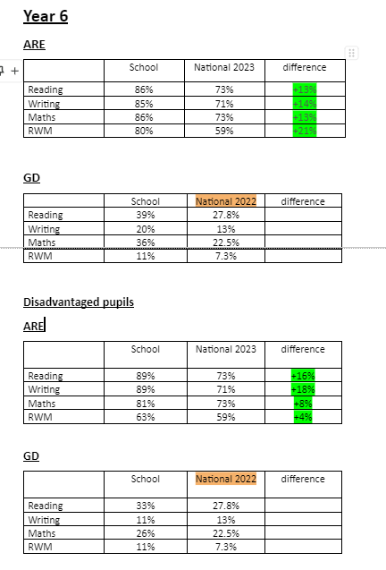

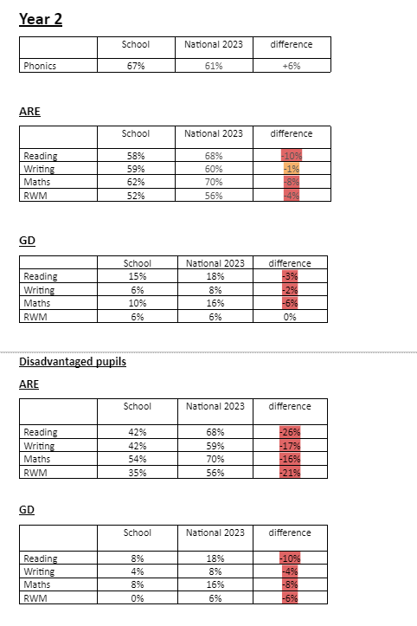
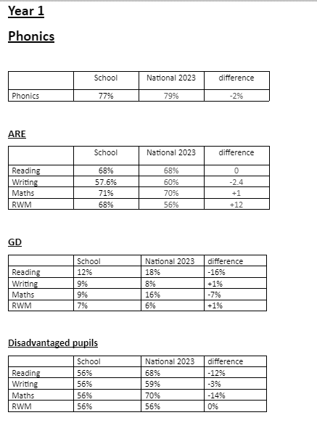
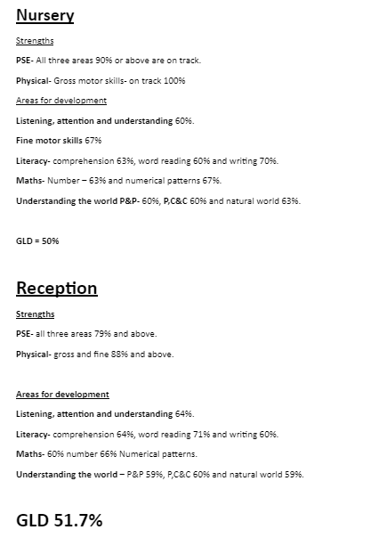

Externally provided programmes
Please include the names of any non-DfE programmes that you purchased in the previous academic year. This will help the Department for Education identify which ones are popular in England
Programme | Provider
N/A

Service pupil premium funding (optional)
For schools that receive this funding, you may wish to provide the following information:
Measure | Details
How did you spend your service pupil premium allocation last academic year? | N/A
What was the impact of that spending on service pupil premium eligible pupils? | N/A

Further information (optional)

